

Briefing Note: Pressure Swing Adsorption, Vacuum Pressure Swing Adsorption, and Vacuum Swing Adsorption
Date published: 4 March 2025
This document was developed by Build Health International for the Global Fund’s Project BOXER.

1. Introduction
The objective of this document is to define the three different systems commonly used to produce oxygen at a hospital level:
- Pressure Swing Adsorption (PSA).
- Vacuum Pressure Swing Adsorption (VPSA).
- Vacuum Swing Adsorption (VSA).

Similarities of the Three Systems
PSA, VPSA, and VSA all produce high purity (approximately 93%) oxygen by separating the oxygen from nitrogen in atmospheric air. All three systems achieve this by passing compressed air through a granular bed specialized material known as zeolite. Under pressure, nitrogen will stick to the surface of zeolite. Thus, the zeolite acts as a filter removing most or all of the nitrogen from the air stream, leaving high purity oxygen at the output. In an oxygen generator, many small pieces of zeolite fill a tank, called a sieve bed. Pressurized air passes through the sieve bed in the oxygen generator, and nitrogen sticks to the zeolite. Once the zeolite has become saturated with nitrogen, the nitrogen can be removed by lowering the pressure in the oxygen generator. At low pressure, the nitrogen will detach from the surface of the zeolite. Once the nitrogen has been removed from the zeolite, the zeolite is ready to repeat the process to filter more air and produce more oxygen in a continuous cycle.

This fundamental process of air separation is identical between PSA, VPSA and VSA. The three systems differ in their pressure levels and the equipment they use to achieve the separation.

Pressure Swing Adsorption (PSA)
In a PSA plant, there are two sieve bed tanks in the oxygen generator. An air compressor pressurizes the incoming air to a high pressure (4.5-7 bar). An air dryer is needed because moisture in the air condenses at high pressures. There is an air storage tank before the oxygen generator. The air enters the oxygen generator and two sieve bed tanks alternate producing oxygen and releasing nitrogen back to the outside air to create a near continuous production of oxygen. Because the incoming air pressure is high, the oxygen pressure at the end of the system is high enough to be delivered directly to wall-mounted oxygen outlets (3.5-5 bar). The oxygen can also be fed directly to a high pressure booster to fill cylinders.

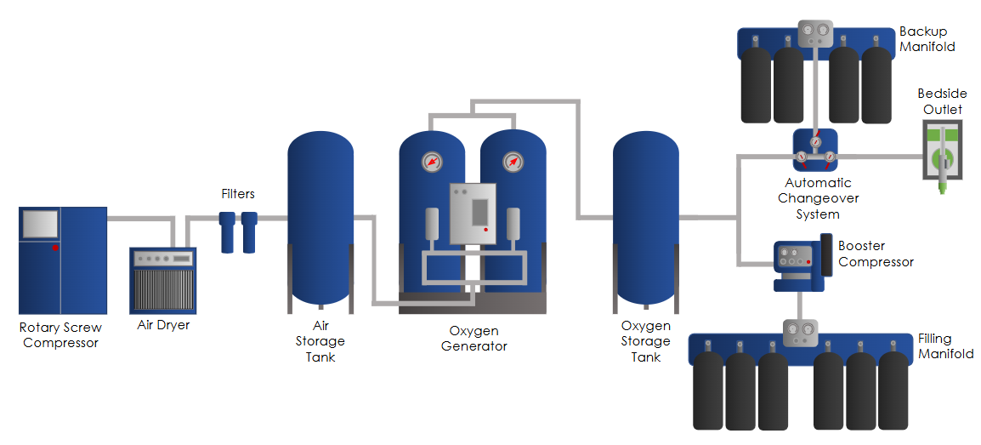

Vacuum Pressure Swing Adsorption (VPSA)
In a VPSA plant, there are two sieve bed tanks in the oxygen generator. There are two air-handling elements: a lobe compressor and a vacuum pump (generally an additional lobe compressor going in the opposite direction). The lobe compressor pushes air into the two sieve bed tanks under low pressure (approximately 0.5 bar gauge). Similarly to a PSA plant, the two sieve bed tanks alternate producing oxygen and releasing nitrogen back to the outside air. The vacuum pump pulls the nitrogen exhaust out of the sieve bed tanks. The oxygen then goes to a buffer tank at approximately 0.5 bar. The oxygen pressure at the end of the system is not high enough to be delivered directly to wall-mounted oxygen outlets. At least one additional oxygen compressor is needed to increase the pressure for direct piping. The oxygen is pressurized to 5 bar by a scroll compressor and is stored in a 5 bar oxygen storage tank. From this point, the oxygen can be fed to the hospital oxygen network or to the high-pressure booster to fill cylinders.
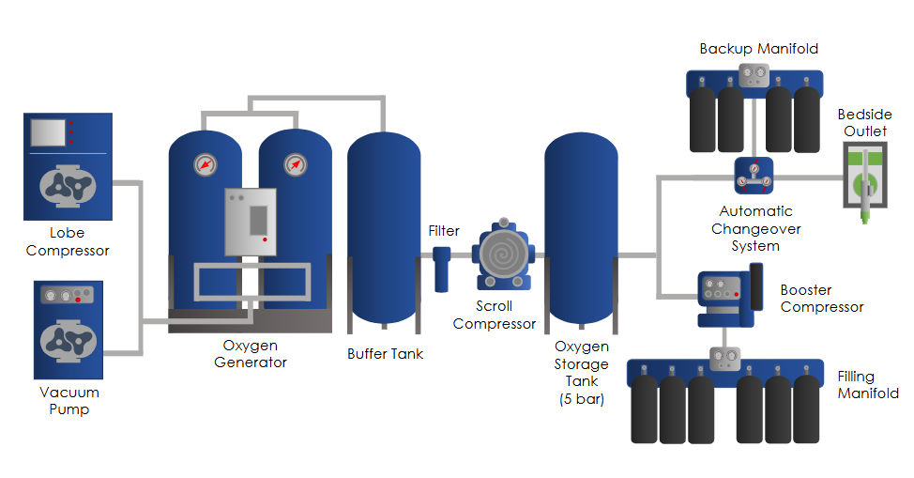

Vacuum Swing Adsorption (VSA)
In a VSA plant, there is one sieve bed tank in the oxygen generator. A lobe compressor is the sole air-handling element. The lobe compressor pushes air into the single sieve bed tank under low pressure (approximately 0.7 bar gauge). Nitrogen is exhausted from the bed via the same lobe compressor (either running backwards or using valves to switch the inlet/outlet). The oxygen pressure at the end of the system is approximately 0.7 bar and is not high enough to be delivered directly to wall-mounted oxygen outlets. At least one additional oxygen compressor is needed to increase the pressure of the oxygen for direct piping. The oxygen exits the buffer tank and is pressurized to 3-7 bar by a scroll compressor. From this point, the oxygen can be fed to the hospital oxygen network or to the high-pressure booster to fill cylinders.

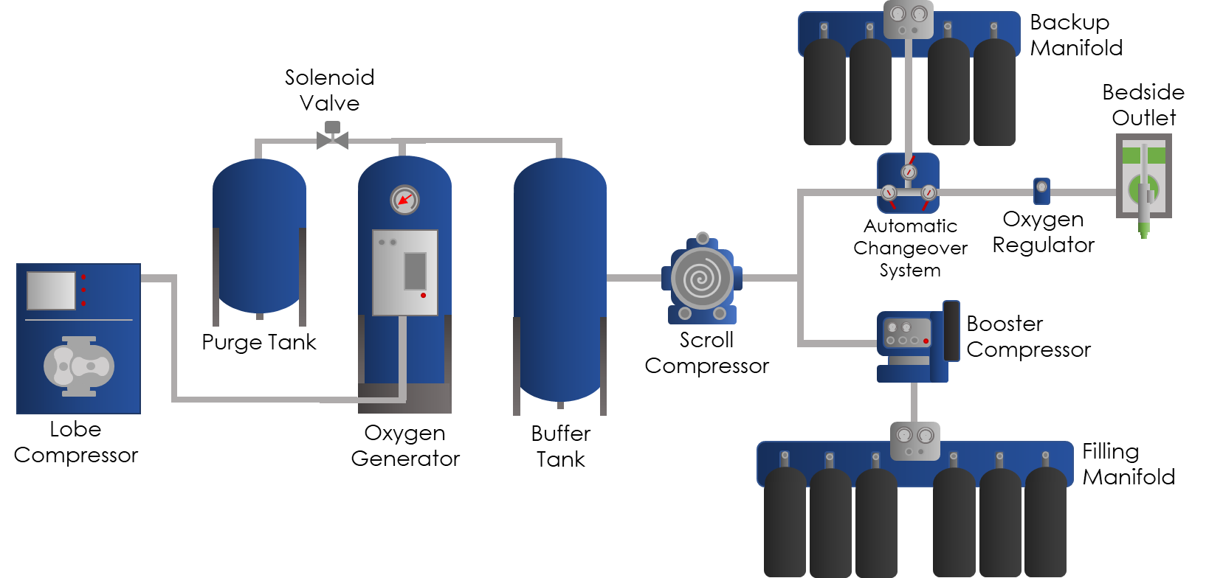

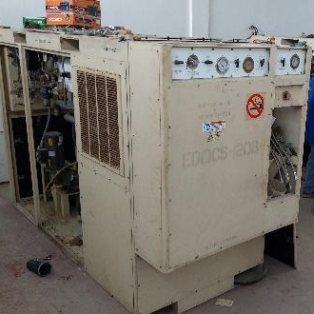
2. Technology Comparison
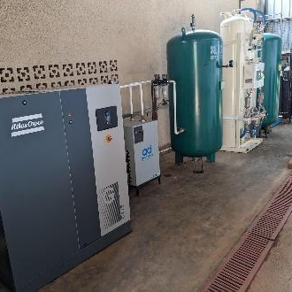
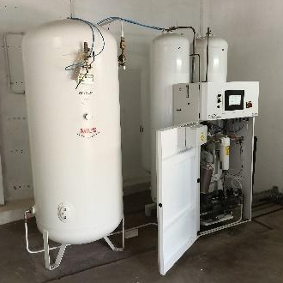
Figure 1: PSA Plant Figure 2: VPSA Plant Figure 3: VSA Plant

Technology | PSA | VPSA | VSA
Air Handling | Rotary screw compressor and air dryer | Lobe compressor | Lobe compressor (also called a reversible blower)
Air Pressure entering Sieve beds | 5-7 bar | ~0.5 bar | ~0.7 bar
Number of Sieve Bed tanks | 2 | 2 | 1
Nitrogen Exhaust | No equipment. Nitrogen exhausts because the sieve beds are at a higher pressure | Vacuum pump | Lobe compressor (also called a reversible blower). Same equipment used for air handling
Oxygen Compression for Piping @4-6 bar* | None | Scroll Compressor | Scroll Compressor
Valve Power | Solenoid Valves: Electricity  Air Actuated Valves: Compressed air from rotary screw compressor | Solenoid Valves: Electricity  Air Actuated Valves: Dedicated air compressor | Solenoid Valves: Electricity
*If National Standards require piping to be above 6 bar, an additional medium pressure booster can be used to increase the pressure from 4-6 bar up to 11-12 bar

3. Benefits and Drawbacks
Technology | Benefits | Drawbacks
PSA | - Oxygen exits the oxygen generator at the pipeline delivery pressure, at approximately 4 bar, which is often suitable for delivery pressure. An additional oxygen booster is not needed.  - Wider knowledge base due to more common components.  - More established supply chains and service networks. | - Large PSA plants can have high air compressor electrical in-rush currents. The generator and switchgear must be sized for this in-rush current.  - More filters are required in the system due to the presence of oil in the rotary screw compressor, and these filters will require filter replacements.
VPSA | - Lower average power consumption when compared to PSA plants.  - Lower risk of condensate due to lower operating pressures when compared to PSA plants. | - Requires an additional oil-free oxygen booster compressor for distribution.  - May require an additional air compressor to supply the air actuated valves  - Additional compressors add potential failure points which increases the risk of plant breakdown  - There have been reports of low purity with these systems. From this, some manufacturers note that this technology is more appropriate for larger industrial applications.  - In countries where such plants are not common, spare parts supply chains and maintenance support may not be optimal.
VSA | - Lower average power consumption when compared to PSA plants. However, power savings may not be realized for smaller plants.  - Lower risk of condensate due to lower operating pressures when compared to PSA plants. | - Peak operating power is the same as PSA plants. VSA requires the same size generator and switchgear as PSA.  - Requires an additional oil-free oxygen booster compressor for distribution.  - Highly specialized maintenance tools are required which are very expensive  - In countries where such plants are not common, spare parts supply chains and maintenance support may not be optimal.

4. General Recommendation
When deciding which technology is the best fit for a particular context, the most important factor to consider is the type of oxygen generating technology already common and functional in the region. If there are existing oxygen plants that are functioning well, BHI recommends pursuing more oxygen plants of the same technology to standardize the tools, skills, and expertise needed to maintain the equipment. Functioning oxygen plants indicate that there are technicians in the region with the knowledge to maintain that particular technology. Additionally, it indicates an established supply chain for spare parts. In general, recipients of oxygen plants should procure familiar technology that has a history of success in their country and in the region.

