Briefing Note: Duplex PSA Plant Configurations

Date Published: 11 October 2023
This document was developed by Build Health International for the Global Fund’s Project BOXER.

Introduction

Duplex pressure swing adsorption (PSA) plants are PSA plants configured to use two smaller plants to satisfy the total identified oxygen need. The two smaller plants are capable of running as individual oxygen production lines,or they can be run in parallel as one large oxygen production unit. The components of a typical PSA plant are labeled in the diagram below.
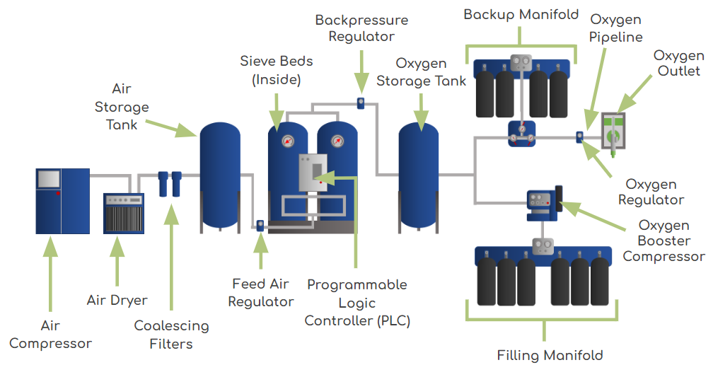
Figure 1: PSA plant components and terminology

In a duplex PSA plant, there are two independent oxygen production lines. Each oxygen production line includes all of the components of a PSA plant from the air compressor to the oxygen storage tank. The outputs of the two lines from their oxygen storage tanks come together to form a single, common oxygen output line that feeds any oxygen booster compressors or oxygen outlets. A single backup manifold is required for a duplex PSA plant system that supplies oxygen directly to an oxygen piping network.
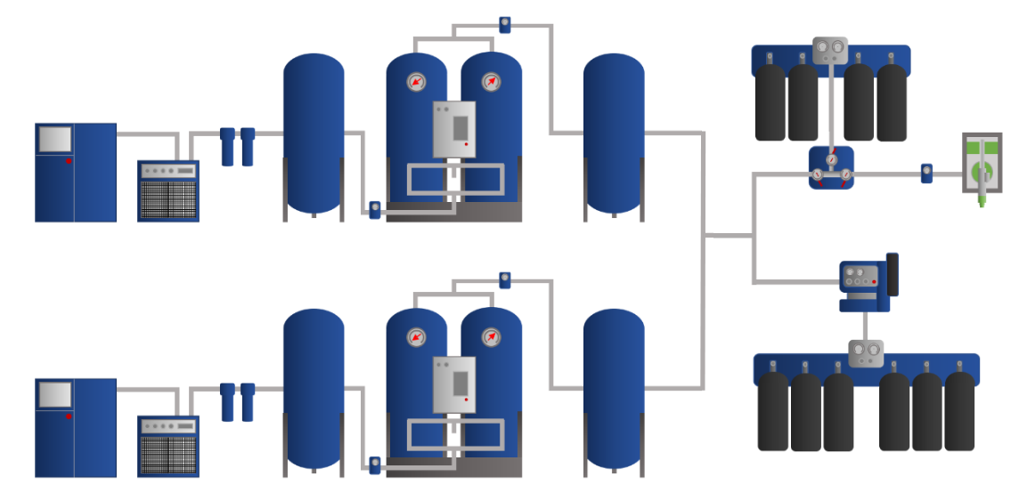
Figure 2: Duplex PSA plant diagram

Advantages of Duplex PSA Plants

- Redundancy: The failure of a plant or maintenance of a plant will not stop oxygen production. For example, a hospital can turn off one half of the plant for preventative maintenance, allowing for continued oxygen production from the other half of the plant. This benefit is critical during times of unexpected failure or issues with the plant that can often take days or weeks to resolve. During these periods of down time, production from the other half of the plant can continue.
- Ease of maintenance: Smaller compressors and PSA plants have smaller spare parts, which makes them easier to manage, store, and maneuver during maintenance.
- Flexibility: PSA plants are generally not able to modulate their power usage based on oxygen demand; they are either off or on. In periods of low demand, unneeded plants can be powered down to save money. Duplex plants can be designed to satisfy a direct piping need with one side of the plant and fill cylinders with the other side of the plant. In times of high demand from the piping network (for example: a COVID-19 surge), the booster compressor can be turned off and both sides of the duplex can supply the piping network.
- Possible decrease in electricity consumption: If the PSA plant is designed such that one side of the plant is often shut down and on standby to respond to heightened oxygen demand, there are potential cost savings related to electricity consumption.

Disadvantages of Duplex PSA Plants

- Footprint: A duplex plant is likely to occupy more space than a single PSA plant solution. If a plant house building is being constructed, more space will be needed to accommodate equipment for both sides of the duplex plant. If a containerized solution is being pursued, additional containers or larger containers could be needed (for example: two 40-foot (12 meter) containers could be needed instead of one, a 40-foot (12 meter) container is needed instead of a 20-foot (6 meter) container)
- Increased number of spare parts and time to maintain: While the equipment and associated spare parts are smaller and more manageable in a duplex plant, two smaller plants will require more spare parts and consumable materials than a single, larger plant. This will mean the purchase and storage of more parts. Additionally, the need to maintain two plants will take more time than maintaining a single plant.
- Increased capital costs: Procuring two smaller plants to satisfy the oxygen demand is often more expensive than purchasing a single, larger PSA plant.
- Possible increase in electricity consumption: If the PSA plant is designed such that both sides of the plant are running most of the time, it is likely that the electricity consumption will exceed what would have been expected of a single PSA plant and therefore incur more electricity costs.

Other Considerations for Duplex Plants

Interconnected Booster Compressors
In situations where a duplex PSA plant feeds one or more booster compressors, it is advantageous to ensure both oxygen production lines can fill both booster compressors. The diagrams below show cylinder-filling duplex PSA plants. Each duplex has two booster compressors. The image on the left (red) shows each oxygen production line connected to only one booster compressor. In this configuration, if the oxygen production line is not functioning, the booster compressor cannot be used. In the image on the right (green), there is a common oxygen output from the two oxygen production lines. If one oxygen production line is not functioning, there is still oxygen flowing to both booster compressors. If one side of the duplex plant (one oxygen production line) has sufficient output, both booster compressors may still be used. The option on the right maximizes the redundancy of the duplex plant.
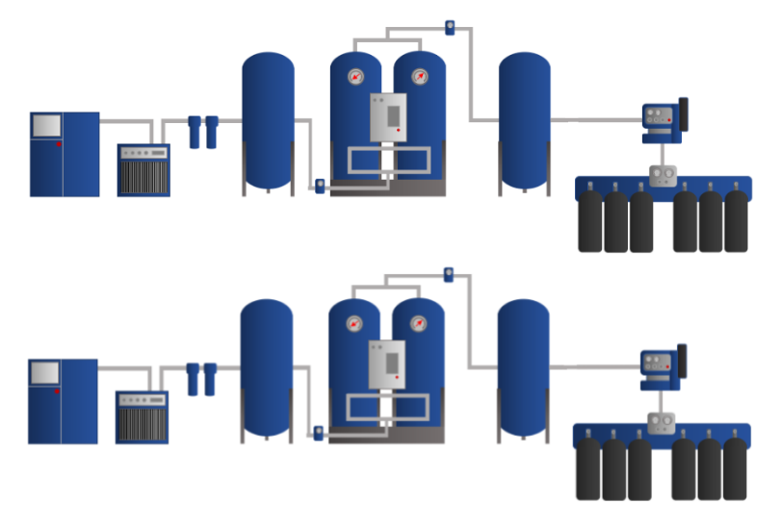
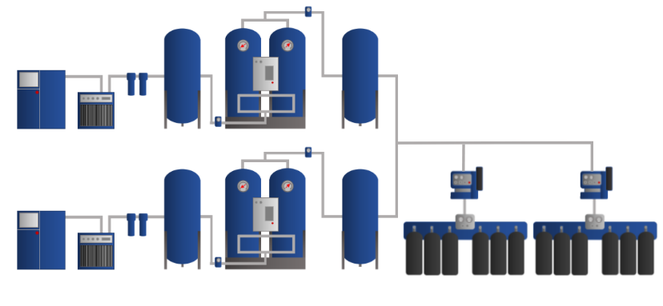
Figure 3. Cylinder-filling plants without interconnected boosters (left) and with interconnected boosters (right)

Triplex PSA Plants
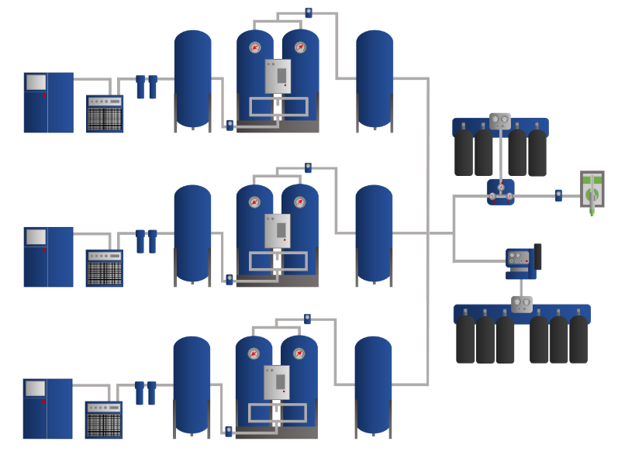
In rare cases, there is a need for a PSA plant with an extremely high oxygen production capacity. Implementing a single plant to provide a very large amount of oxygen is risky, as any maintenance or unscheduled shutdowns of the plant result in a significant loss in oxygen production. Additionally, PSA plants of such high capacities may not be commercially available. Where PSA plant experience and supply chains are well established, triplex PSA plants may be an option in special cases. A triplex PSA plant is similar to a PSA duplex plant, except that instead of having two oxygen production lines, the triplex plant has three. The diagram below shows an example of a triplex plant that combines the outputs of the three oxygen production lines into a single, common output that supplies any booster compressors and oxygen outlets. The oxygen piping network, as shown in this diagram, is supported by a single central backup manifold.
Figure 4. Diagram of a triplex PSA plant

