Briefing Note: Centralized vs Decentralized Approach to Oxygen Access

Published: 23 August 2023
This document was developed by Build Health International for the Global Fund’s Project BOXER.
For countries requiring increased access to medical oxygen there are two main models they can choose from when deploying PSA plants:
- The decentralized approach in which oxygen is supplied through many small PSA plants distributed across the individual points of use, ie. at hospitals or facilities with patients requiring oxygen.
- The centralized approach, or ‘hub-and-spoke’ model, where one large plant produces and stores all of the oxygen in the form of high pressure cylinders for distribution. Often a secondary system distributes this oxygen to specific locations for hospitals to pick up from.
Just one model doesn’t have to be selected for an entire country or MoH, different regions may have different needs. There could be many centralized production plants each serving their own cluster of hospitals throughout a country, or one region may be better suited for centralized while another requires a decentralized approach.
Deciding which model is best for your country based on cost effectiveness and sustainability is dependent on local context and conditions. There is no one correct approach and the advantages and disadvantages of each will have to be weighed in every situation.
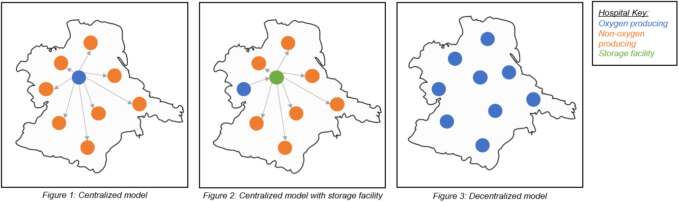

 | Decentralized Approach | Centralized Approach
.  .  .  .  A  D  V  A  N  T  A  G  E  S  .  .  .  . | More resilient and redundant, as one failure (of a PSA plant or electrical grid) will not take out the whole system or greatly reduce the total production capacity.  Elimination of transportation costs and challenges as cylinders are created at or closer to their final destination.  Decentralized PSA plants can be connected directly into a piping network, eliminating the need for cylinder filling as the primary mode of distribution, thus further reducing costs and cylinder management  Unit cost is cheaper for machine parts as it is easier to bulk stockpile / acquire.  More skilled laborers are trained to service the higher number of plants. | Equipment costs less to run & maintain if not considering transportation costs.  Requires less power overall.  Will run more efficiently as a cylinder filling plant can store the maximum output.  Significantly less maintenance will be required as there are few machines. Thus less trained staff are needed, decreasing costs.
.  .  D  I  S  A  D  V  A  N  T  A  G  E  S  .  . | Limited economy of scale as it requires many localized systems in place to operate and maintain a large amount of equipment  Less energy efficient overall (KW/m³) for O2 reaching patients, leading to more energy costs system wide.  Greater maintenance costs system wide as each site requires spare parts and detailed maintenance plans.  Greater HR costs and time required to identify, train, and hire enough qualified personnel. | Significant transportation costs and challenges. Often difficult or impossible to distribute cylinders due to geography and weather.  Substantial initial investment in operational equipment, such as trucks, garages, cylinders, storage areas, hand carts, etc.  A detailed inventory management system must be put into place to track and distribute cylinders across the network.  Major outages or service issues impact the entire system. Power reliability and maintenance is much more critical as the system is less resilient with potential for a single point of failure.

Case Studies

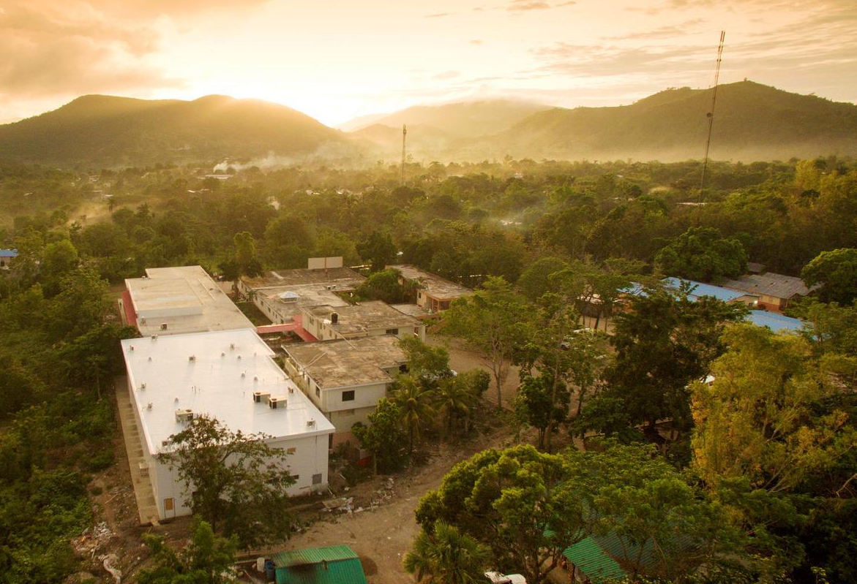
Haiti – Centralized
On the Tiburon Peninsula of Haiti, a centralized model of oxygen production is being utilized. A solar-powered plant at St. Boniface Hospital fills 60-100 oxygen cylinders each day. The cylinders are then transported to a storage facility in Les Cayes, 2 hours west of the hospital. From Les Cayes, oxygen can be distributed to 16 facilities needing oxygen within a 2-4 hour drive from the storage facility.
The centralized approach allowed St. Boniface Hospital to cut costs through energy saving processes and utilizing solar power – both of which would have been difficult in a decentralized model. Further, the equipment, tools, and level of training required to support the ongoing maintenance of a decentralized model are not available in this region of Haiti.
Figure 1: Aerial view of St. Boniface Hospital
The use of an additional storage facility brought the oxygen closer to the other 16 hospitals, shortening overall road travel and reducing transportation issues common in the centralized model. Clever positioning further allowed hospital drivers to avoid roads in poor condition, and areas with frequent roadblocks due to political unrest and weather conditions.
Liberia – Decentralized
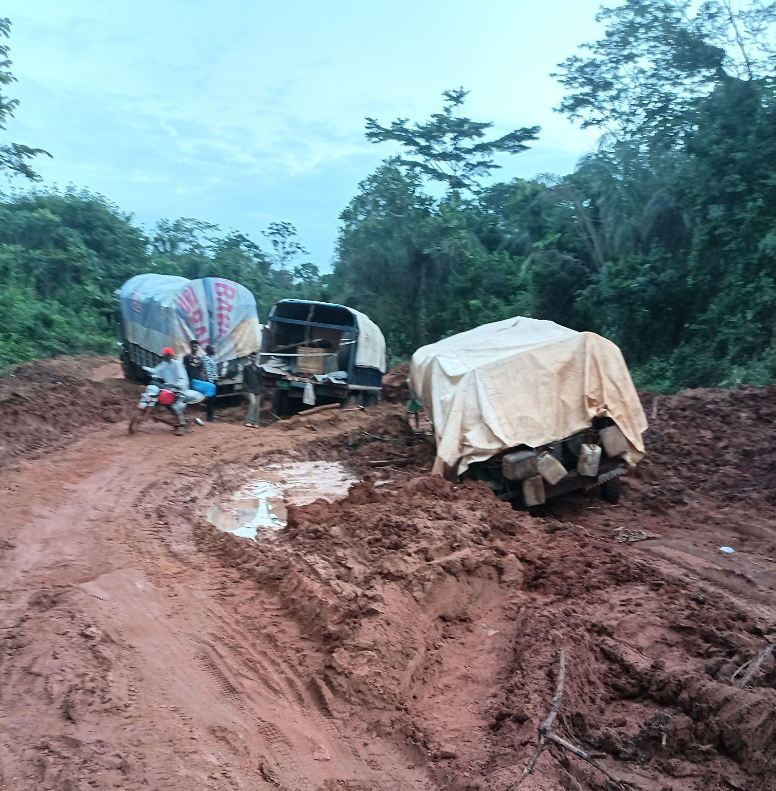
A decentralized model of oxygen production is being utilized in Liberia. The redundancy of many small PSA plants eliminates transportation time and logistical issues which may be prevalent in a centralized model. Liberia’s road conditions represent their largest barrier to oxygen as many sites were separated by long distances and sometimes impassable roads. During the rainy season, road blocks due to tipped or stuck trucks are common and round-trip travel times to the previously used centralized PSA plant often surpassed 12 hours. These conditions are dangerous for drivers and make deliveries extremely unreliable – potentially leaving patients without oxygen for extended periods of time.
The redundancy of many small PSA plants located at multiple individual facilities allows for reliable on-site production of oxygen and decreases dependency on outside sources. Opposed to a centralized model, this method minimizes impact of a plant shutdown as surrounding plants will still be producing oxygen and could potentially even share surplus.
Figure 2: Road block in Liberia
due to muddy roads

