Briefing Note: Cylinder valves on high pressure oxygen tanks

Date: 6 January 2025
This document was developed by Build Health International for the Global Fund’s Project BOXER.

This document outlines the different valve designs for high pressure oxygen cylinders. These designs are due to differing valve standards and are generally not interchangeable. This requires attention in order to purchase compatible oxygen cylinders and accessories based on the specific valve standards applicable for a particular hospital. This resource is intended to inform persons of the different oxygen cylinder valve types available based on locally applicable standards and how to identify the cylinder valve type currently in use in their facility, region or country. This document does not recommend any specific cylinder valve type. It only recommends using the most compatible valve type accessible through the supply chain.

Large Cylinders Valves "Bullnose Valves”

Most large cylinders of oxygen, >5L of volume are fitted with larger valves with threaded connections, as opposed to the "pin index" connections found on smaller portable cylinders. Such valves are commonly referred to as bullnose valves. This Document will primarily concern bullnose valves; however pin index valves are briefly covered at the end. All of these valves are similar in several respects:
- The threaded nut does not form a gas tight seal. Thread tape should not be used on these threads as it will not stop leaks. The threaded nut is designed to push the nipple tightly against the opening of the valve outlet.
- The gas tight seal is formed by the nipple pressing against the valve opening. Contact between the surface of the nipple and the inside surface of the valve opening form a gas tight connection. Both the nipple and the valve outlet are designed to mate closely with each other to form the seal.

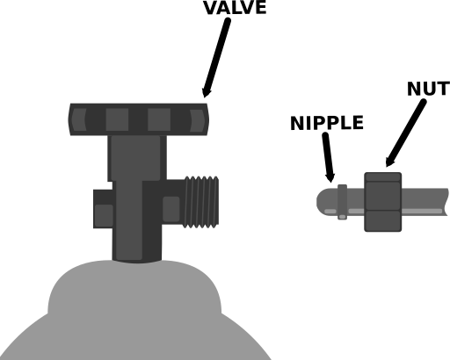
Standards and Countries

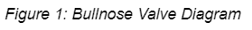
Valve types are specified by different standards (listed in the references) created by organizations based in different countries or regions. For example, in the United States and Canada, the standards body is the Compressed Gas Association (CGA), while in France the body is Association Française de Normalisation (AFNOR). Many countries officially or unofficially (through trade relations) adopt another country's standard as their national standard. For example, Anglophone countries and former British colonies will often officially or unofficially adopt the British Standard. This, however, is not a hard and fast rule. Even in countries where a particular standard is adopted, equipment and cylinders of a
competing standard are often found in hospitals. These non-standard cylinders are commonly supplied by foreign NGOs.

Table 1: Prevalent Standardizing Bodies
Country | Standards Body
USA | Compressed Gas Association (CGA)
United Kingdom | British StandardsInstitute (BSI)
France | Association Française de Normalisation (AFNOR)
Germany | Deutsches Institut für Normung (DIN)
China | National Standards of the People's Republic of China (GB)

Identifying Cylinder Valve types

Identifying the exact cylinder valve type can often be difficult. Many valve types look alike. Furthermore some manufacturers do not put obvious markings on the valve specifying the standard and type. The following guide is not exhaustive but should be helpful in identifying many oxygen cylinder valves in circulation.

The two best features for determining cylinder valve types are:
- Markings on the valve itself
- Valve and nipple features

In all cases, background information on the cylinder or equipment is helpful. For example, what country is this in? Did a foreign NGO supply it?
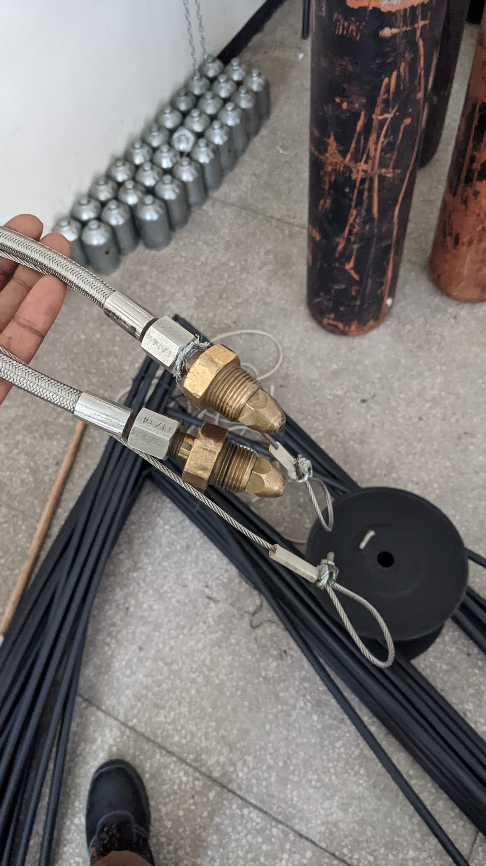
Figure 2: Two British (BS341 #3) cylinder whips from a manifold

Markings
The exact specification for a cylinder fitting type is generally referred to by some combination of the standards body, the relevant standards document, as well as design type for the particular gas, in this case oxygen. For example, the standards body for cylinder valves in the United Kingdom is the British Standards Institute (BSI). BSI's standard document BS341.3 "Transportable Cylinder Container Valves: Part 3 Valve Outlet Connections" includes the dimension and specifications for "Outlet No. 3" which is used for oxygen gas. As such, this oxygen valve connection is often specified by BS-3, BS341 no.3, BS341.3 no. 3, or British Standard Oxygen.

See Table 2 and the Picture Glossary (Page 8) for examples of these markings. The two rightmost columns in Table 2 list markings likely to be found on the valve itself.

Table 2: Standards and associated markings
Country | Standards Body | Standard | Oxygen Connection | Often specified by | Also marked as
USA | CGA | CGA V-1 | 540 | CGA540 | CGA540
United Kingdom | BSI | BS341-3 | No. 3 | BS #3, BS341 No.3, BS341.3 No.3 | BSI BS-3
France | AFNOR | NF E29-650 | Type F | NF-F, AFNOR Type F | NF/F, SI 22.91
Germany | DIN | DIN 477 | No. 9 | DN-477-9, DIN477 no.9 | DIN9
China | GB | GB 15383 | Type 9 and 10 |  | G-5/8

Markings can also be found on whips and regulators attached to the cylinder, however, caution should be taken to only look at the nipple and nuts directly connected to the cylinder (ignore any markings on nipples, nuts and valves connected to manifolds). Be aware of nipples and whips marked as British parts in areas where you would expect French equipment.
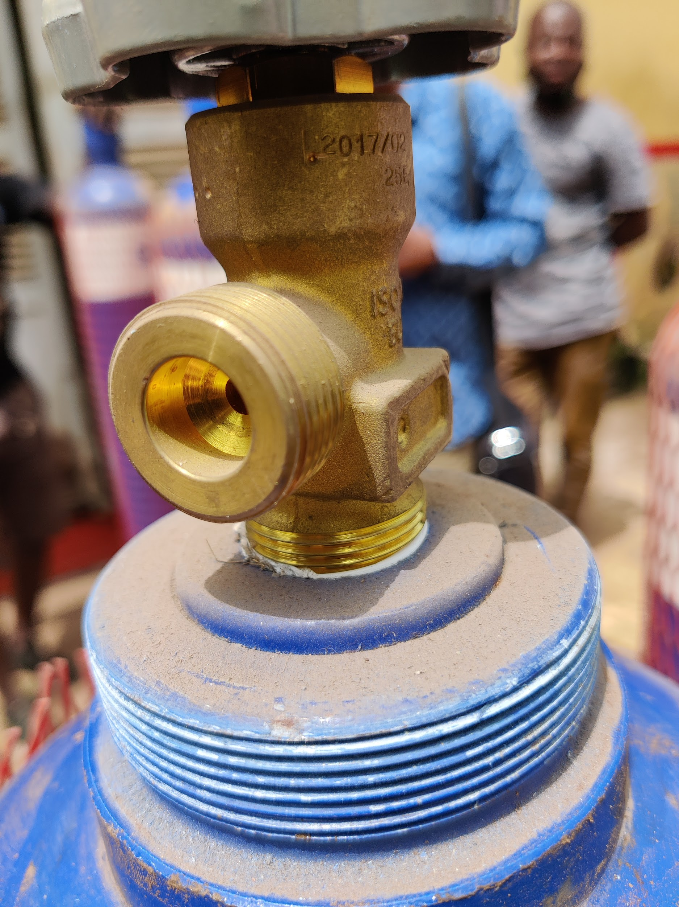
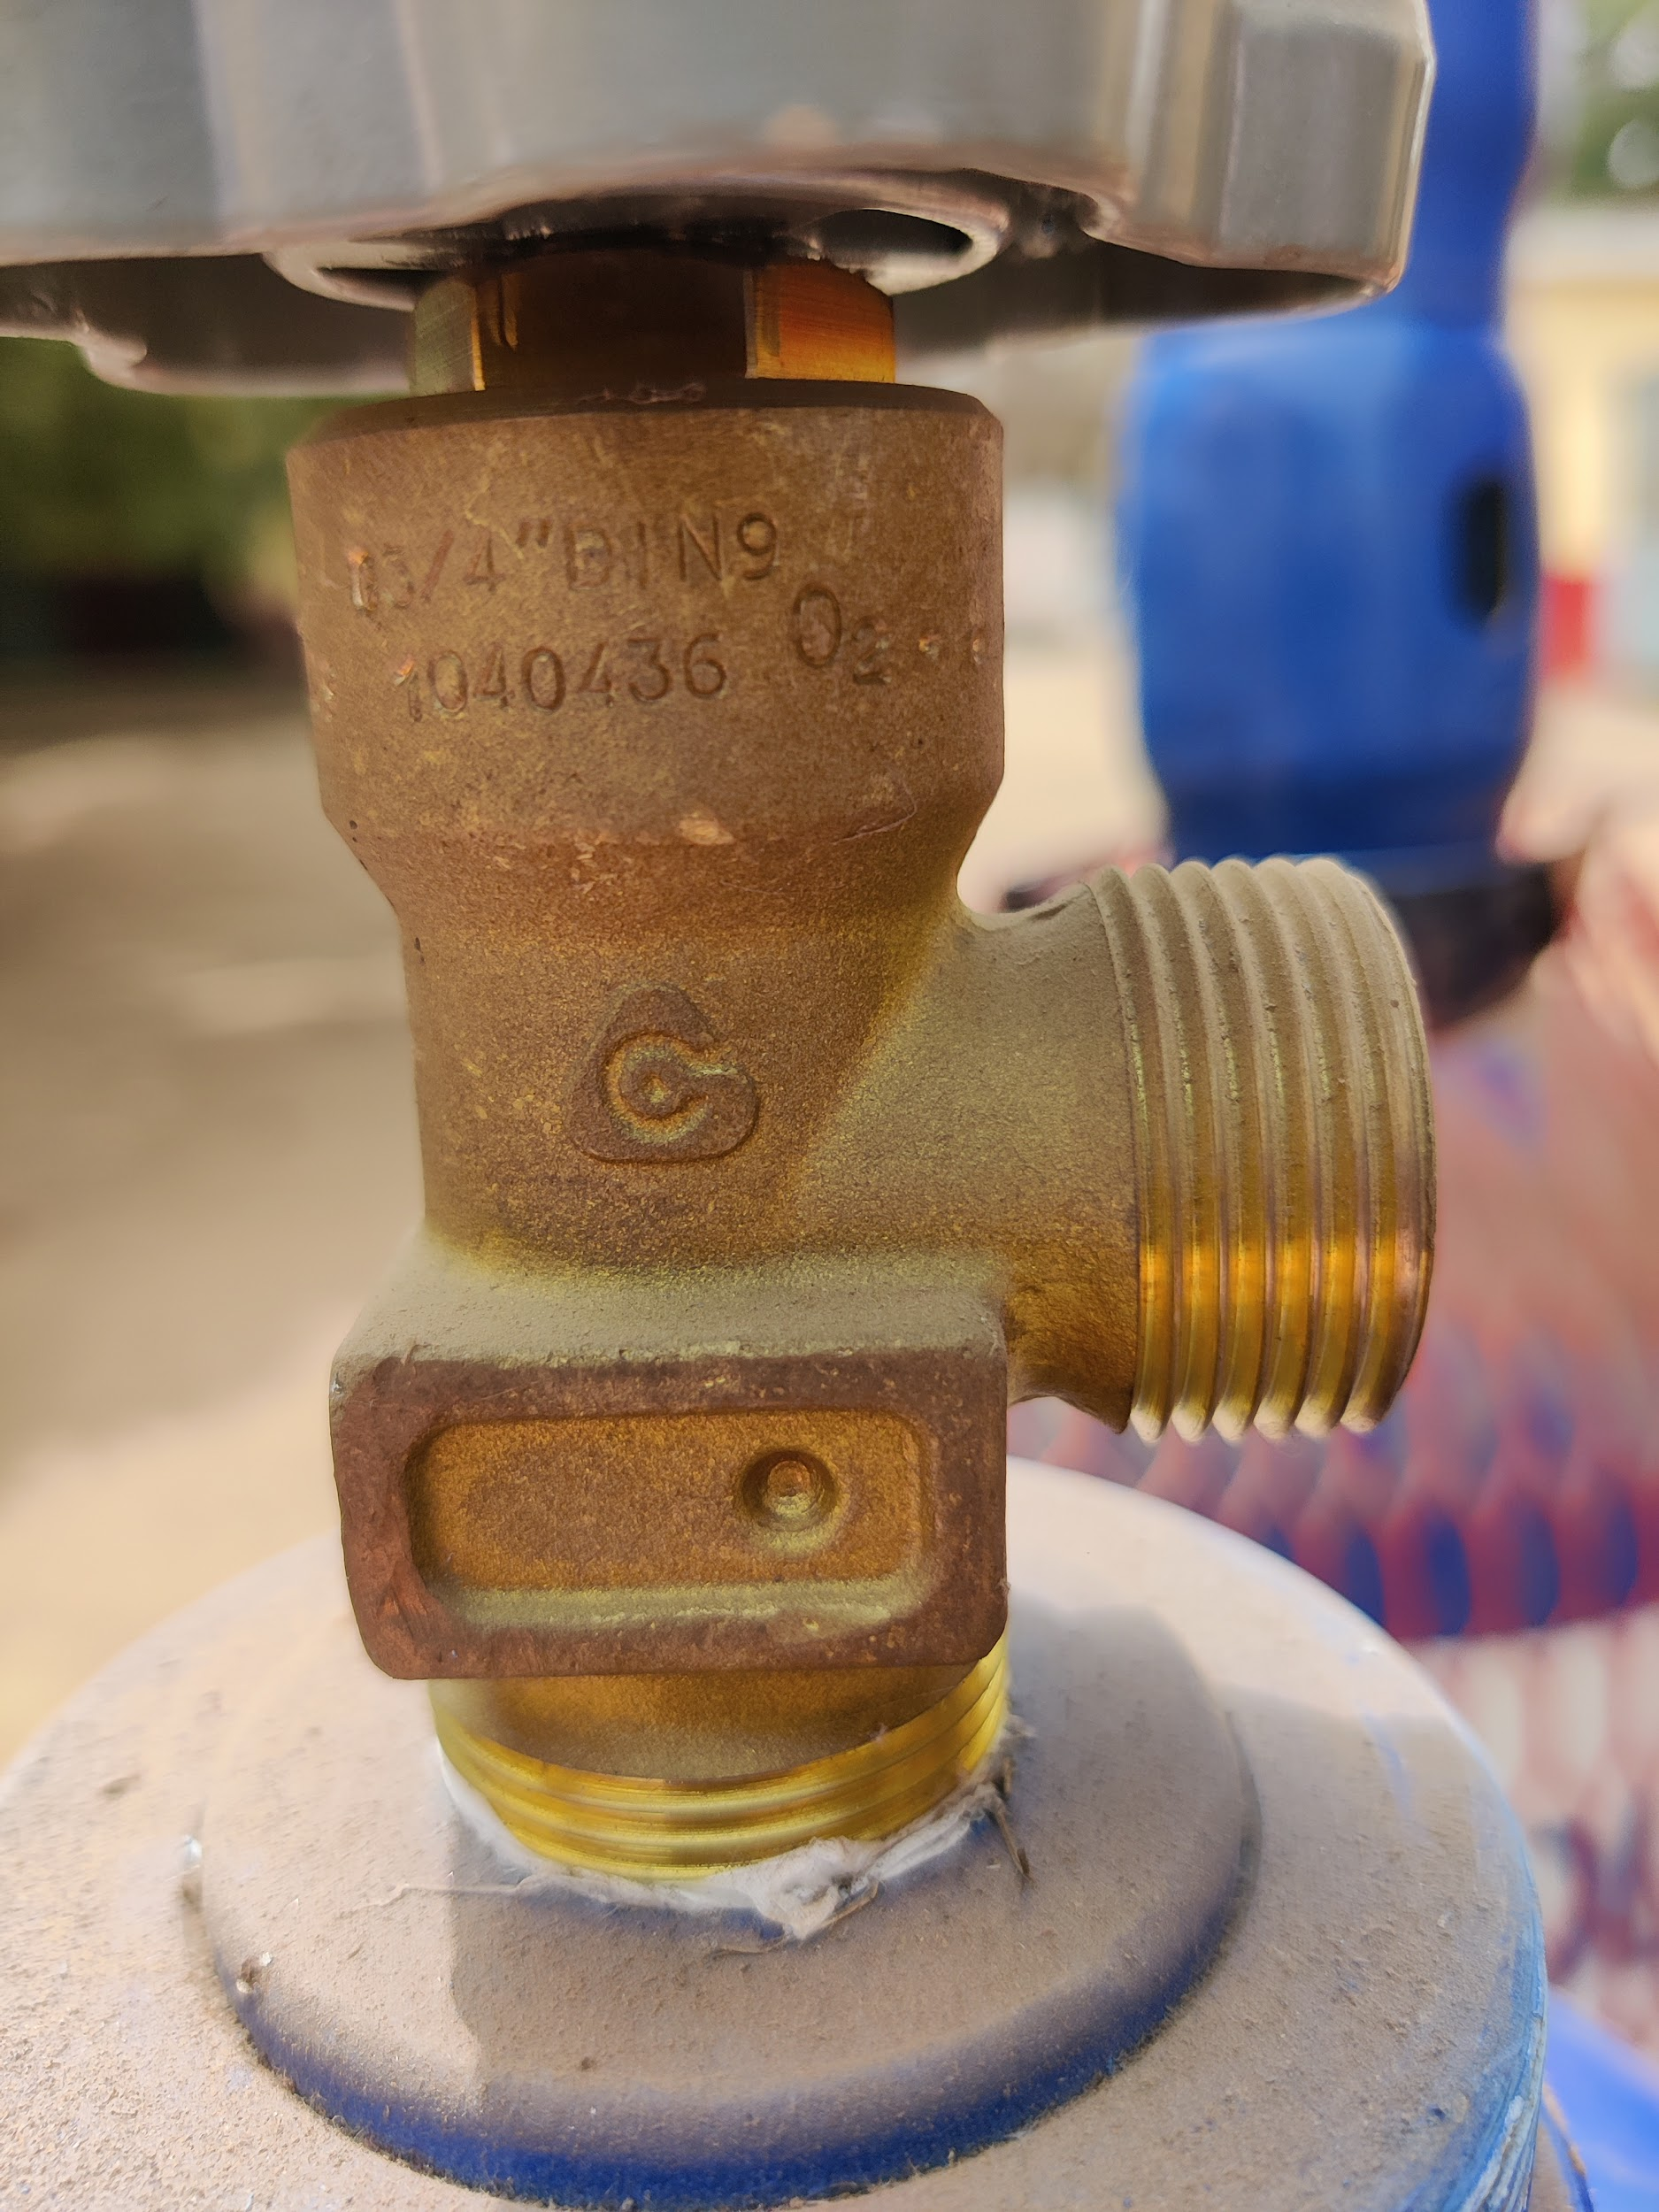
Note: the "DIN9" Marking
Figures 3 & 4: German valve examples with identifying markers

Features
Observing both the oxygen cylinder valve and nipple from a regulator or whip that attaches to the cylinder can help identify the valve type if markings are not found. Be careful to make sure that the whip or regulator you are observing works well with the cylinder. Reports of the nipple leaking and thread tape on the valve or nut are signs that the nipple may not match the valve. Figure 5 is a flow chart to help identify which valve type visually.

Figure 5: Valve type identification diagram

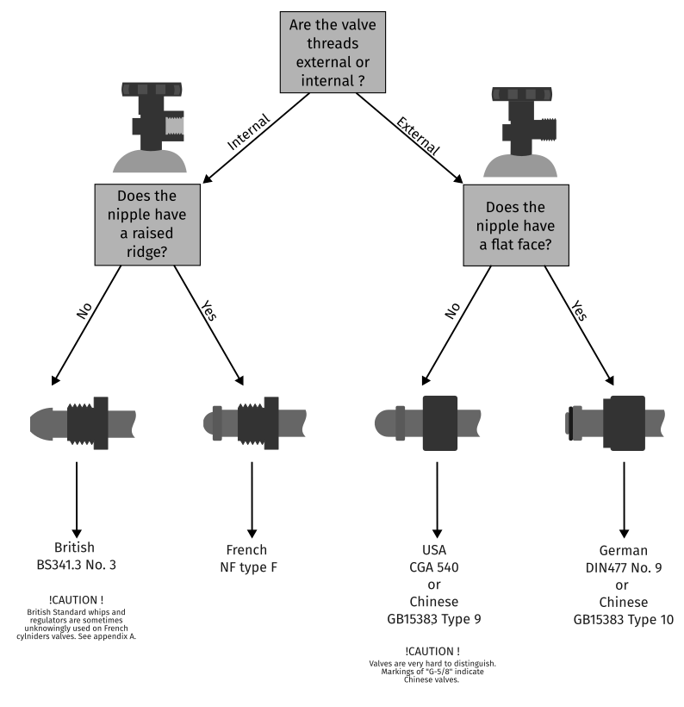

Pin Index Valves
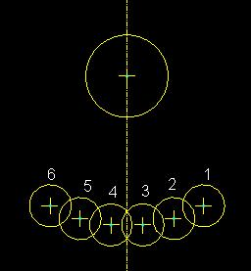
Pin index valves (see Figure 7) are used for smaller cylinders (generally < 5L) for numerous medical gasses (oxygen, nitrous oxide, medical air, etc). Like the larger "bullnose" valves, the pin index valves are designed to prevent equipment from being connected to gasses for which they are not designed. Pin index valves achieve this by having "yoke" connectors with male pins that will only mate with matching holes on valves corresponding to the correct gas. Sealing is achieved with a soft washer/gasket affixed to the yoke. There are two virtually identical standards specifying the pin index valves and yoke connections for medical gasses: CGA V-1 and ISO 407. Pin index valves for medical oxygen use pins 2 and 5, which shows the pin locations used for all gasses. See Figure 6. CGA and ISO oxygen pin index valves are interchangeable. The oxygen pin index valve is known as CGA 870. ISO 407 requires that the "oxygen" or the symbol "O₂" be indelibly marked on the valve.
Figure 6: Pin Index Safety
System Numbers

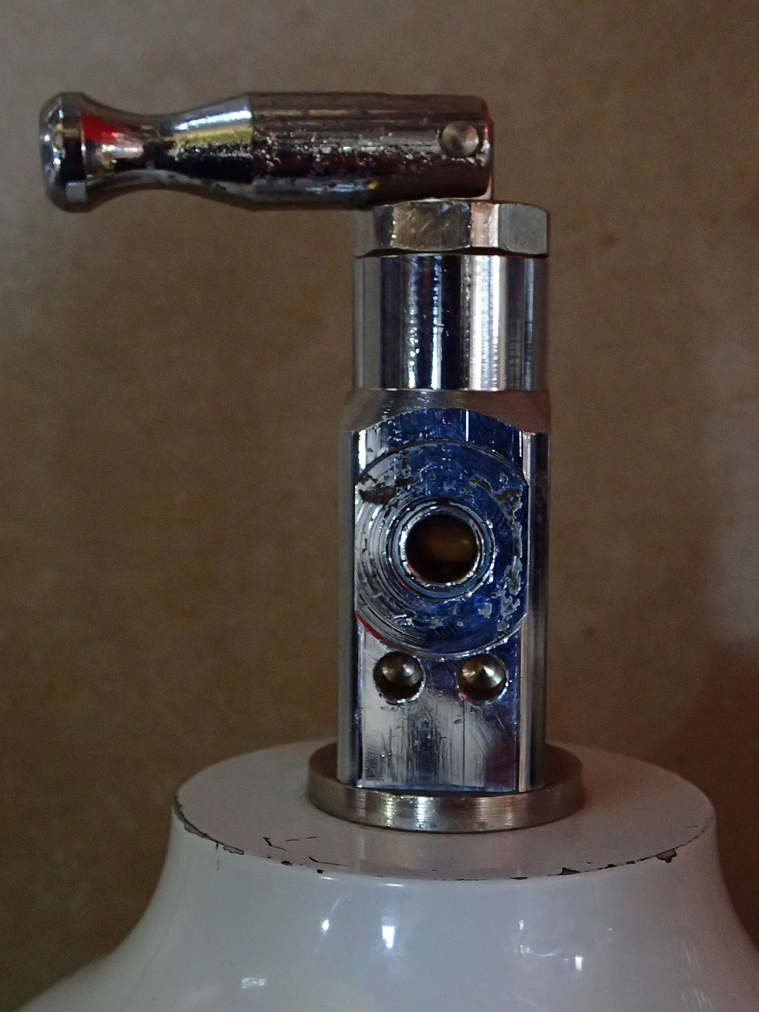
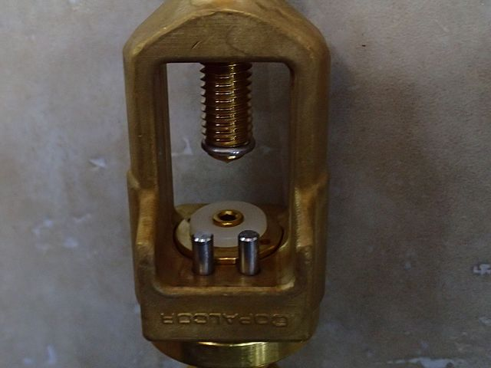
Source Peter Southwood

Figure 7: Oxygen pin index valve

References
In-text citations
[1] EN ISO 407:2023(E). Small medical gas cylinders - Pin index yoke type valve connections.
[2] Handbook of Compressed Gases, (3rd ed.). 1990. Arlington, VA: Compressed Gas Association

Standards
- BS 341-3:2002, Transportable gas containers valves, Part 3: Valve outlet connections
- CGA V-1: Standard for Compressed Gas Cylinder Valve Outlet and Inlet Connections
- DIN 477:2021. Gas Cylinder Valves For Cylinder Test Pressures Up To 300 Bar - Valve Inlet And Outlet Connections.
- GB 15383 - 2011. Connection Type and Dimensions for Gas Cylinder Valve Outlets
- NF E 29-650 :2020. Gas cylinder - Valve outlet connections for cylinders and bundles

Appendix A

British and French oxygen cylinder valves appear identical externally and have been misreported as being interchangeable. This is untrue. Because of the similarity it is not uncommon to find British whips and regulators used with French standard valves. While this is not recommended and presents an added risk, BHI is not aware of any catastrophic events owing to this combination. When identifying a cylinder valve in francophone countries, the use of a British nipple on whip or regulator may not positively identify the valve as a British type. Reports of leaks or the presence of pipe tape on threads are signs of a mismatch between cylinder and nipple. See Figure 7.
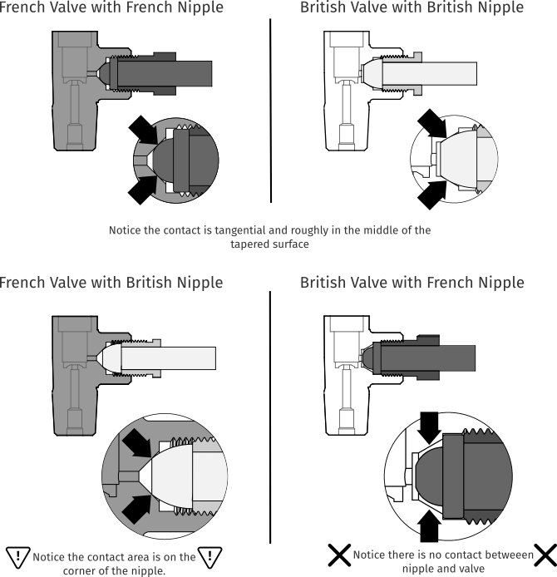
Figure 8: Types of valves and nipples

There are two important differences between the French and British valves: the angle of the internal taper and the "threadform" of the screw. The taper angle gives rise to the difference in the nipple's shape. The French standard uses a taper angle of 90° While the British valve uses an angle of 60°. The larger 90° angle of the French valve means the rounded end of the French nipple can be a smaller diameter. This smaller diameter will not make good contact with the tapered surface of a British valve. On the other hand, a British nipple's larger diameter will make contact with the tapered surface of a French Cylinder. This contact, however, will take place on the front edge of the nipple and not on the rounded surface as designed. Furthermore, depending on the threaded depth of the valve, the British nut may engage few threads presenting an additional risk of damaging cylinder threads or coming loose.

The screw threads on both French and British valves and nuts are nearly identical: each share the same major diameter and pitch. However, their thread form, the cross sectional profile of the teeth, is different. Namely, the British tooth has an included angle of 55°, while the French standard has an included angle of 60°. Depending on manufacturing tolerances, threads may have trouble fitting together.
Picture Glossary

- German Valves
Note: the "DIN9" Marking
Figure 9 & 10: German valve examples with identifying markers

- French Valves
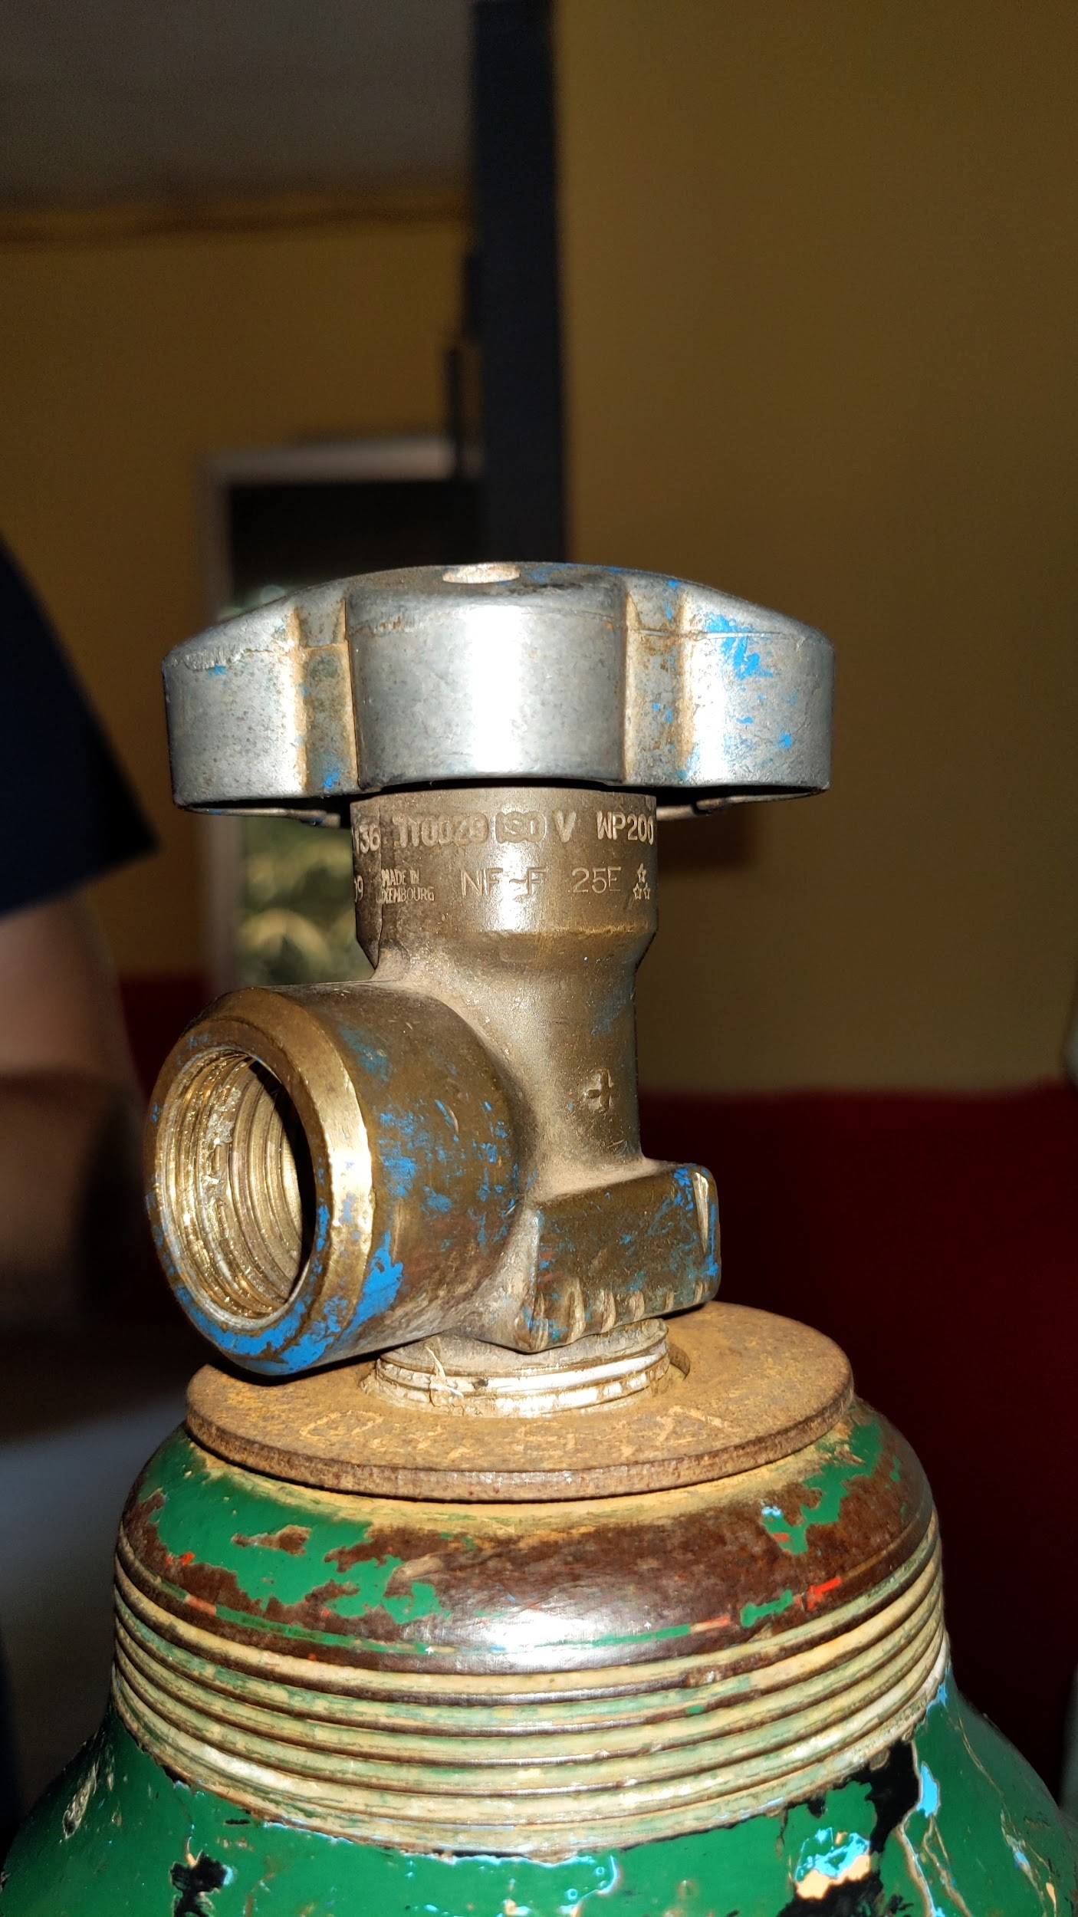
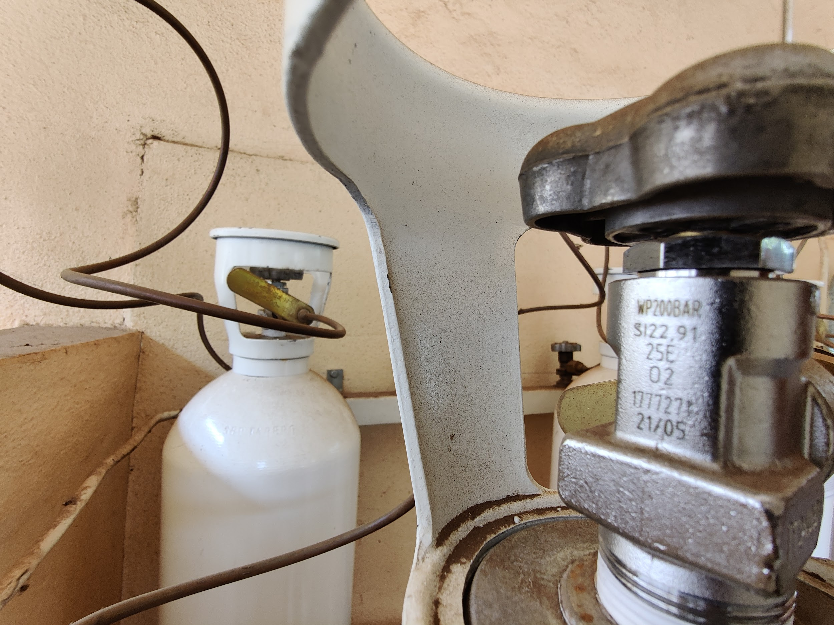
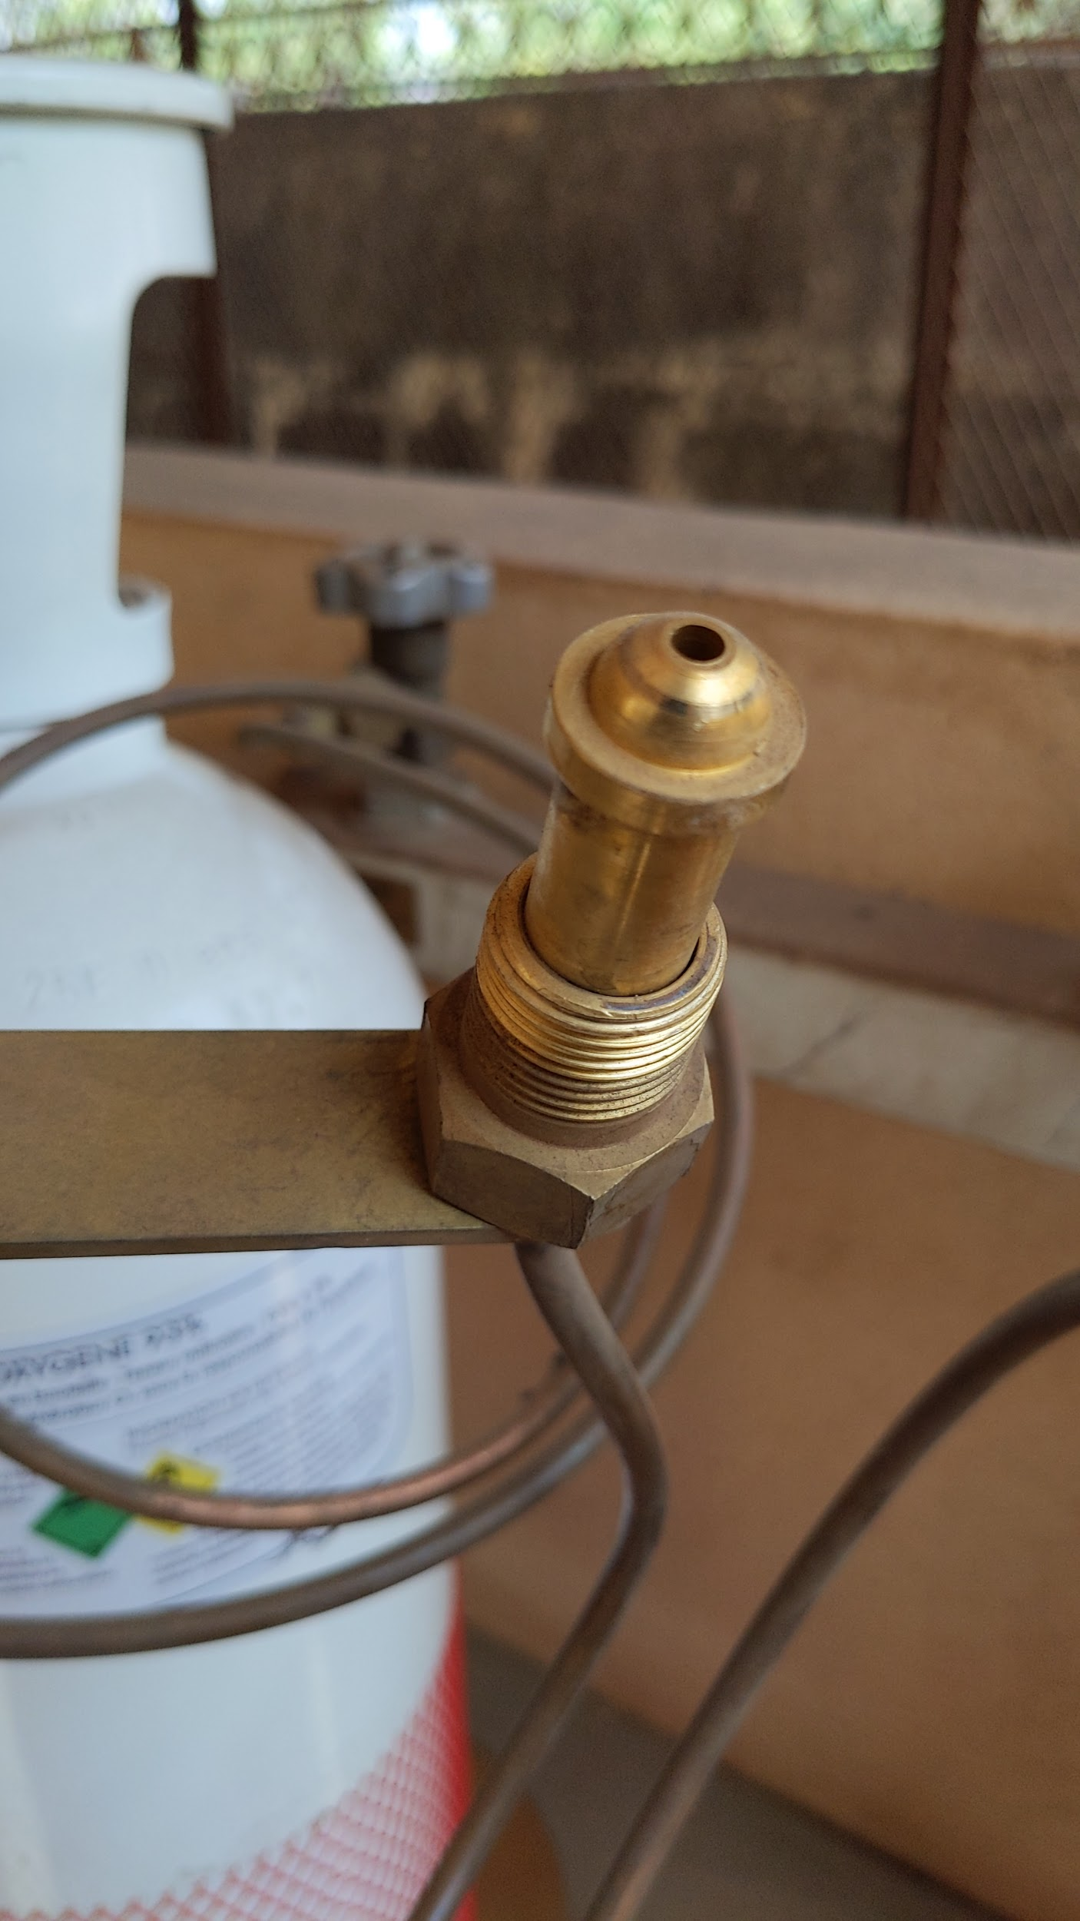
Note the "NF-F" marking
"SI 22.91" refers to the outside diameter and threadform of the outlet thread on the valve. British valves do not use this designation.
Note the raised ridge on the nipple.

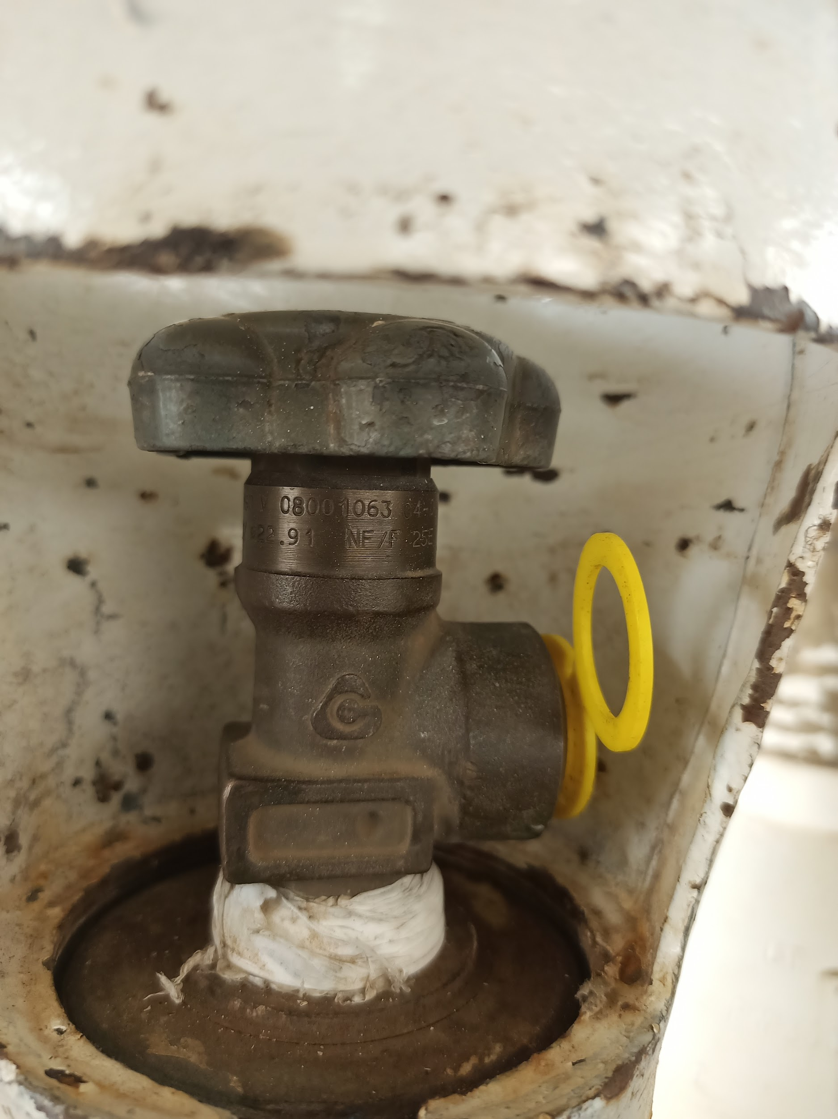
Figures 11 - 15: French valve examples with identifying markers
Note the "22.91" and "NF/F" markings

- British Valves
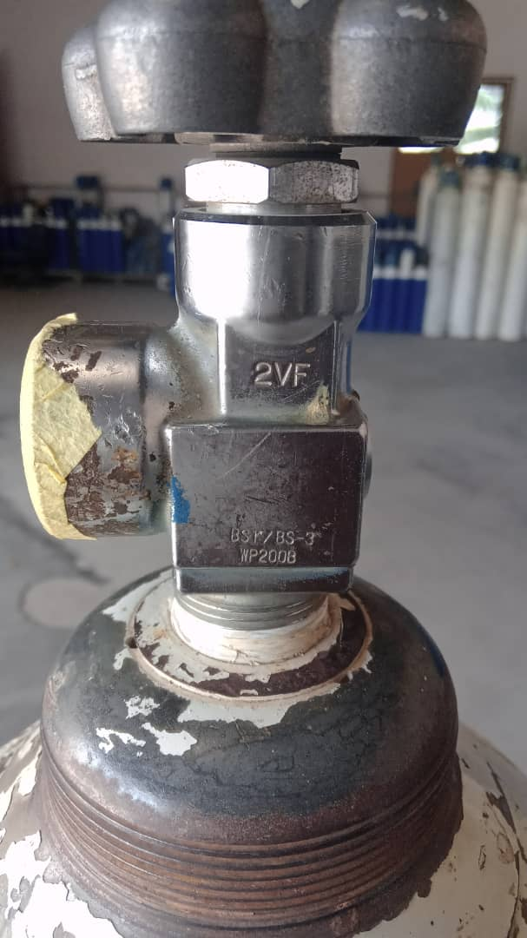
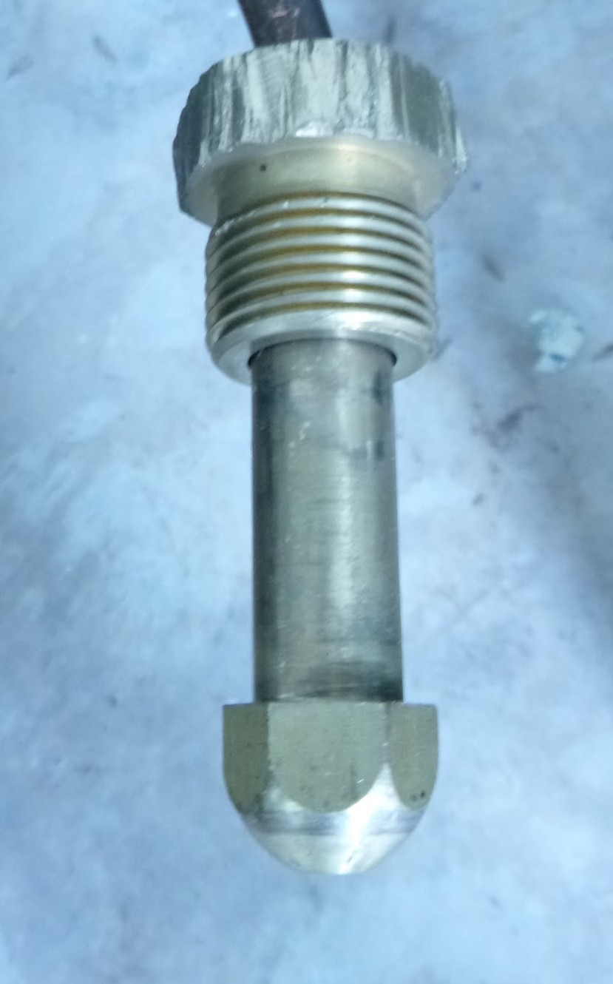
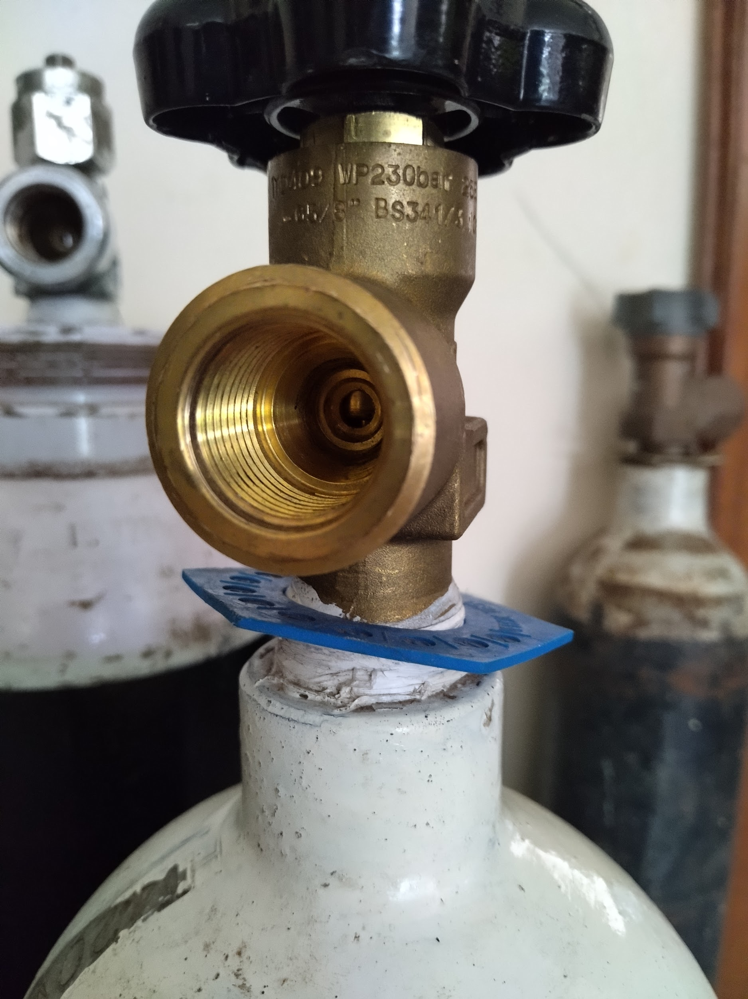
Note the "BSI/BS-3" markings.
Note there is no rim, and the radius is larger than the French nipple
Note the "BS341" marking.

Figures 16 - 18: British valve examples with identifying markers

- USA Valves

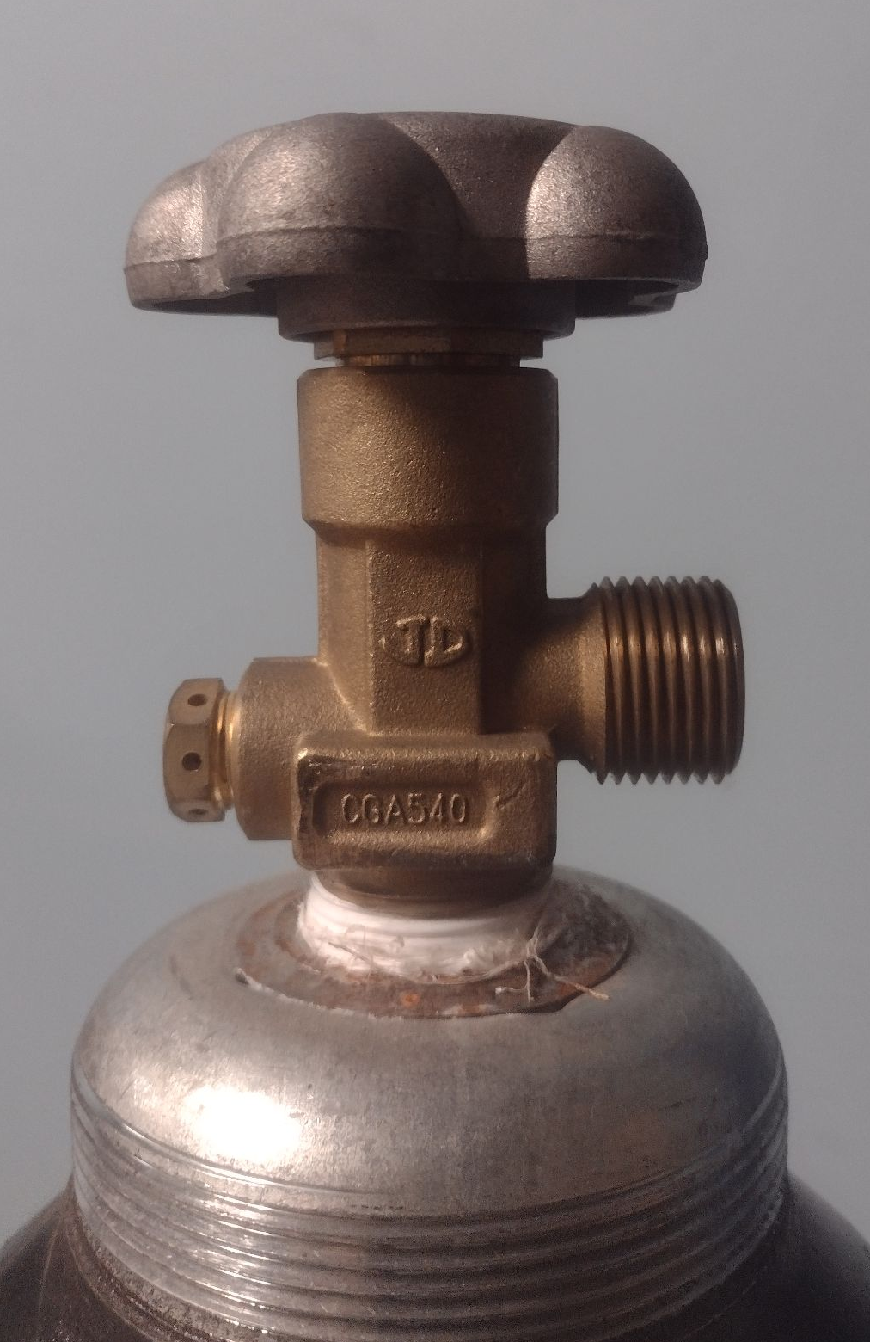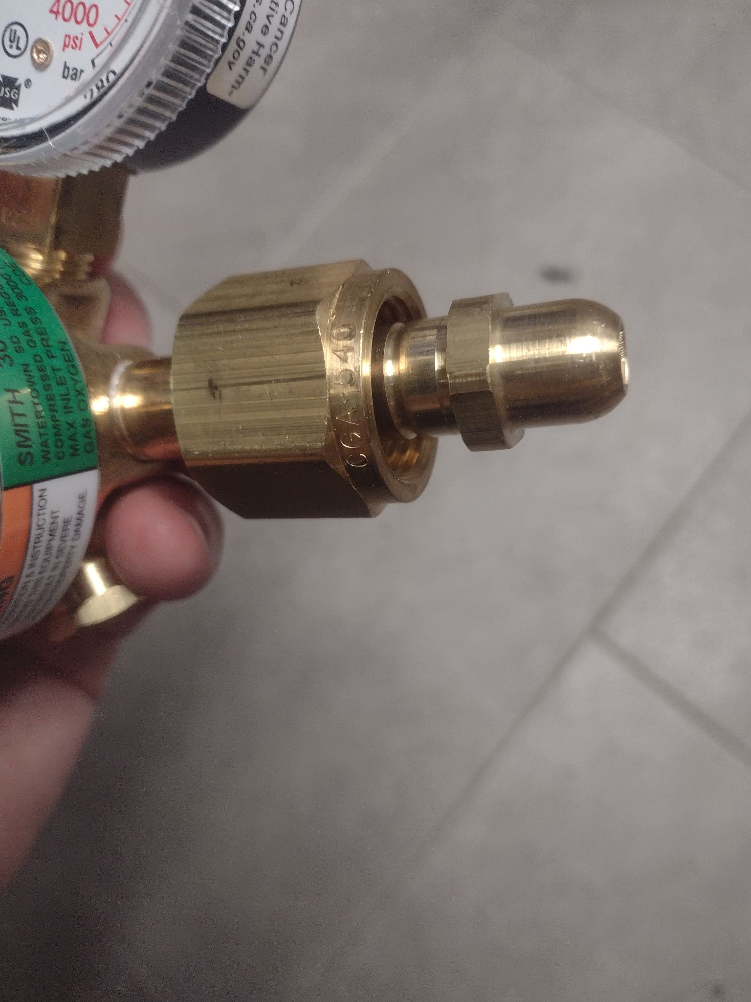
Note the CGA540 markings
Note the CGA540 markings on the nut

Figures 19 & 20: USA valve examples with identifying markers

Bullnose and bullet-nose have been used to describe the rounded nipple of the connection. Here we use the term colloquially to encompass all larger cylinder valves even if they have flat gasket seals.
Screw threads vary between standards; however, identifying the cylinder based on screw thread is not easy. Some threads are specified by there nominal diameter and not the measured diameter (G-⅝" on a British standard valve does not measure ⅝" in diameter). Other threads are very hard to tell apart (G-⅝" and SI 22.91 are identical except for minute differences in the thread profile).
IS3745 (India Standard) has been written to align with ISO 407.
There are slight differences in dimensions and tolerance between CGA and ISO standards conversion of inch units to metric. BHI has not found or is aware of any critical differences that prevent CGA 870 oxygen valve or yoke from working with a ISO 407 oxygen valve or yoke [2].
This does not mean that valves themselves can be installed on any steel cylinder body. Threads in the neck of that valve vary.
This is not conclusive as a reference because BSI341-3 valves may also have G-5/8 marking. However, valves with external threads and a G-5/8 marking indicate GB 15383 Type 9.

