Briefing Note: Cylinder Procurement
For Medical Oxygen

Date: 8 May 2024
This document was developed by Build Health International for the Global Fund’s Project BOXER.
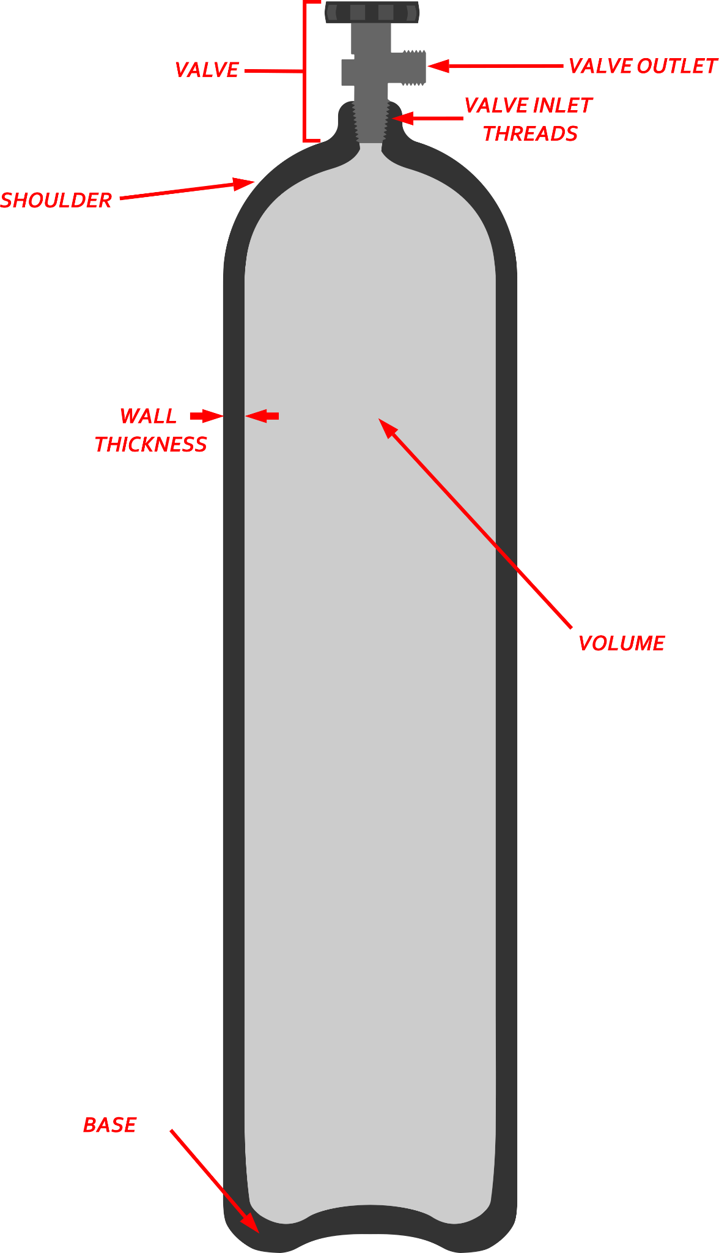
The purpose of this document is to assist procurement teams in making informed decisions when ordering cylinders for medical oxygen use. This briefing note will cover basic cylinder properties and important specifications for tenders. Additionally an appendix is provided for calculating cylinder capacity. Oxygen cylinders can present hazards to patients and staff. Therefore, the design and construction of cylinders are heavily regulated by many governments. There are numerous different national and international standards. Countries may either adopt an international standard or develop their own standard. It is important to consider the standards in your country before purchasing cylinders. If your country does not abide by a specific international or domestic standard, this document will outline relevant ISO (International Organization for Standardization) standards which may be helpful in developing cylinder procurement tender documents.
Figure 1: Cylinder diagram
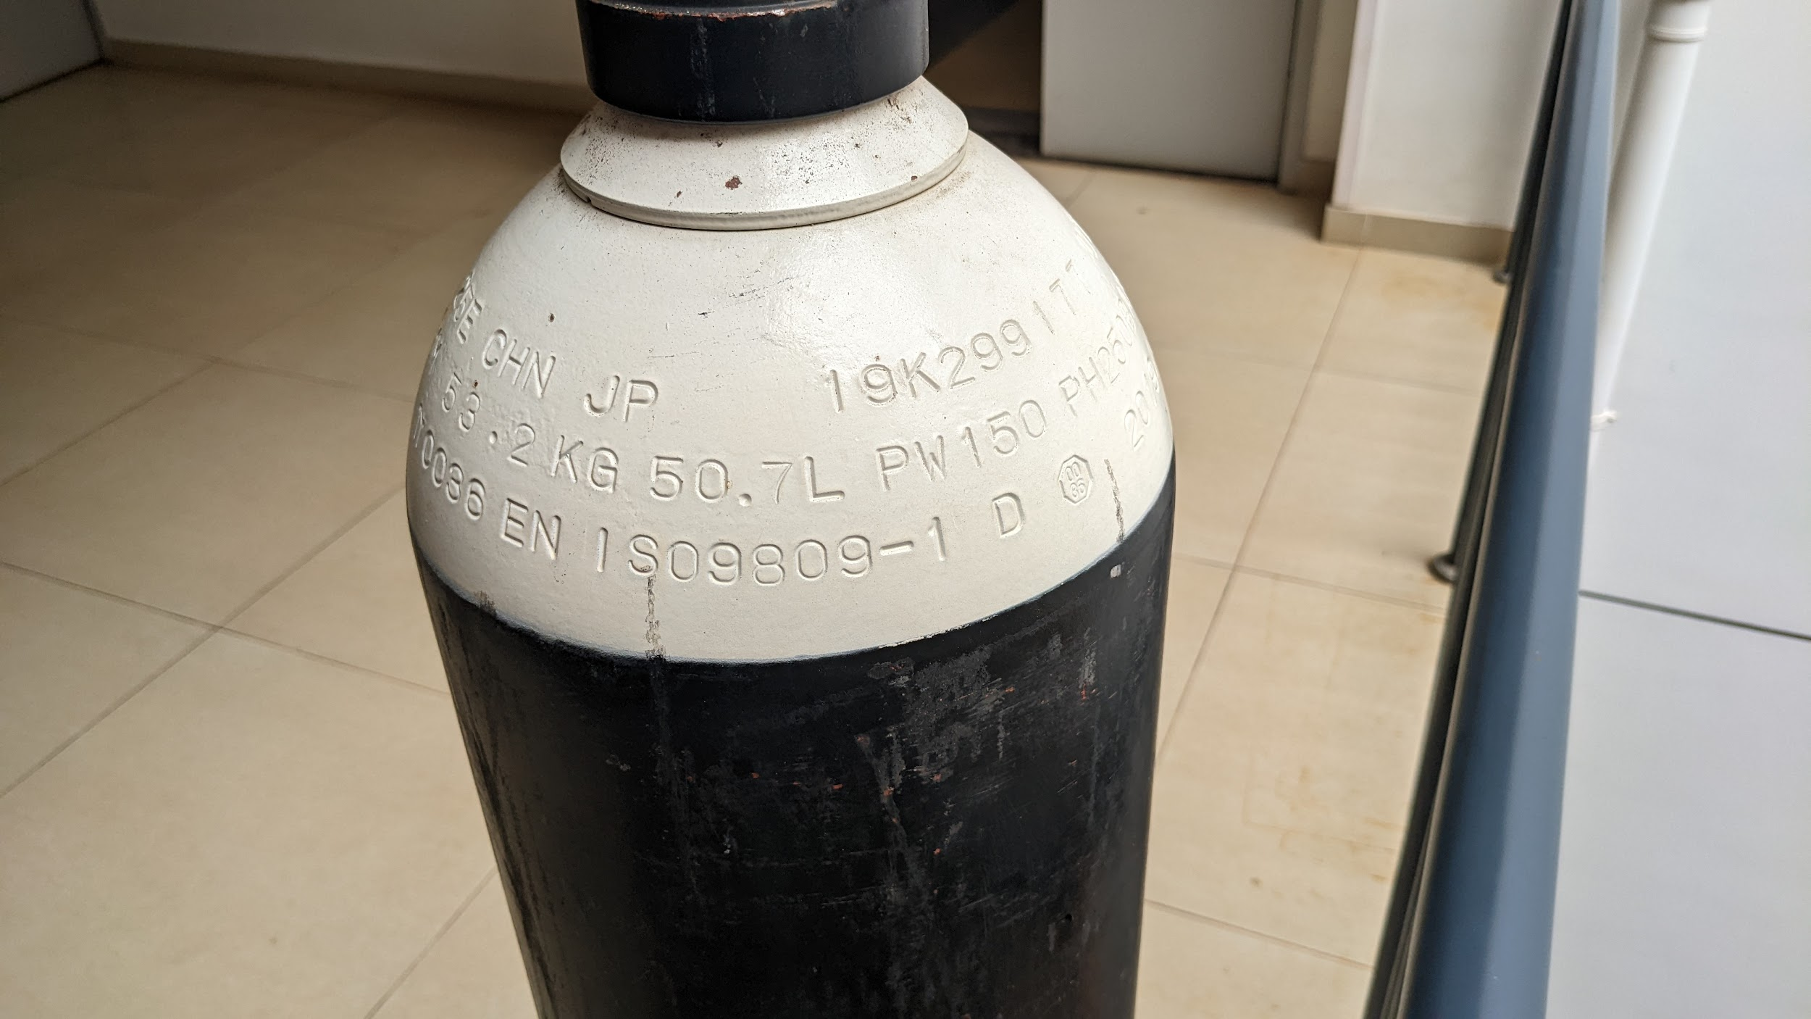
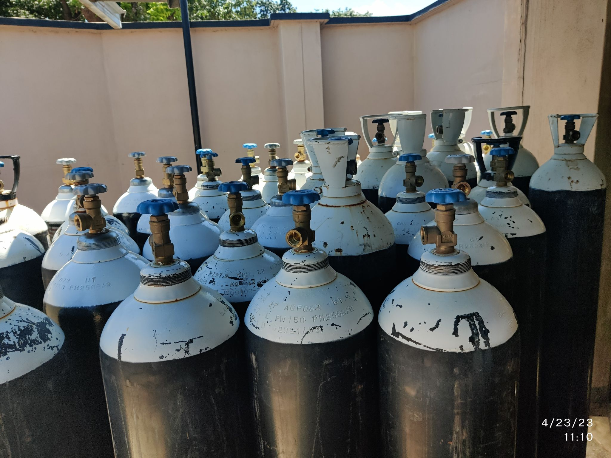
Figure 2: Stamp markings
TEST PRESSURE
WORKING PRESSURE
VOLUME
STANDARD

Cylinder Properties

- Valve: The brass valve controls the flow in and out of the cylinder. The valve inlet threads connect to the steel cylinder. The valve outlet connects to regulators or whips. It is important to make sure the valve outlet matches your equipment.
- Material: The type of material and properties of the material. Cylinders made of different materials will often be governed by different standards. For example, aluminum cylinders are specified by ISO7866 while steel cylinders are specified in ISO 9809. Oxygen cylinders are most often made of steel.
- Volume: The internal volume of the steel cylinder when filled with water. This water volume is stamped on the shoulder of all ISO 9809 cylinders. The water volume is independent of the pressure in the cylinder, as water is practically incompressible.
- Capacity: The volume of room pressure oxygen a cylinder can hold when it is fully filled. For example, a tank with a 1,000 liter capacity could supply a patient using 10 LPM for 100 minutes. The capacity of a cylinder depends on the cylinders volume and what pressure it is filled to.
- Working Pressure: The maximum pressure that the cylinder is designed to operate at. This pressure, in units of bar, is stamped into the shoulder of all ISO 9809 cylinders with the prefix PW. The working pressure is likely not the pressure that the cylinder will be regularly filled to, so it should not be relied on to calculate the capacity of a cylinder.
- Filled pressure: The pressure that the cylinder is filled to by a supplier or on-site cylinder filling equipment. This pressure is at or below the working pressure. The filling pressure depends on the capability and settings of the oxygen booster compressors. In general, it is between 124-140 Bar. This pressure is not stamped into the shoulder of cylinders.
- Test Pressure: The pressure that the cylinder was tested to when manufactured to ensure its structural integrity. It is generally 1.5X the working pressure. This pressure is also stamped into the shoulder of all ISO 9809 cylinders.

Specifying Cylinders

When developing cylinder tender documents, it is recommended to consider the following areas:

Cylinder Size
Some suppliers and manufacturers refer to sizes based on a non-universal letter or number system, the oxygen "capacity" delivered to the patient, or the internal volume of the cylinder. To avoid confusion, it is recommended that cylinder size be specified by the water volume. This is unambiguous and for ISO 9809 tanks will be stamped on the cylinder shoulder.

For manifolds and high flow equipment, it is common to see 45 - 50L cylinders used. For patient transport and ambulances, cylinders commonly vary between 5-30L.

Valve Outlets
Purchased cylinders should be supplied with an appropriate cylinder valve. Valve outlets, which connect to manifolds and regulators, are gas specific, meaning valves for medical air, nitrous oxide, or oxygen cannot be interchanged. Larger cylinders will have what is commonly referred to as a bullnose valve, while smaller tanks may have a pin index valve. There are several different standards for oxygen bullnose valves that are non-compatible with each other, for example CGA 540, BSI 341# 3, or AFNOR type F. Some countries have officially adopted a valve standard while others have not. If no standard has been adopted, it is important that the valve selected matches the valves already in use locally. Identifying cylinder valves can be challenging. See the briefing note on identifying cylinder valve types to help determine what valve is commonly used.

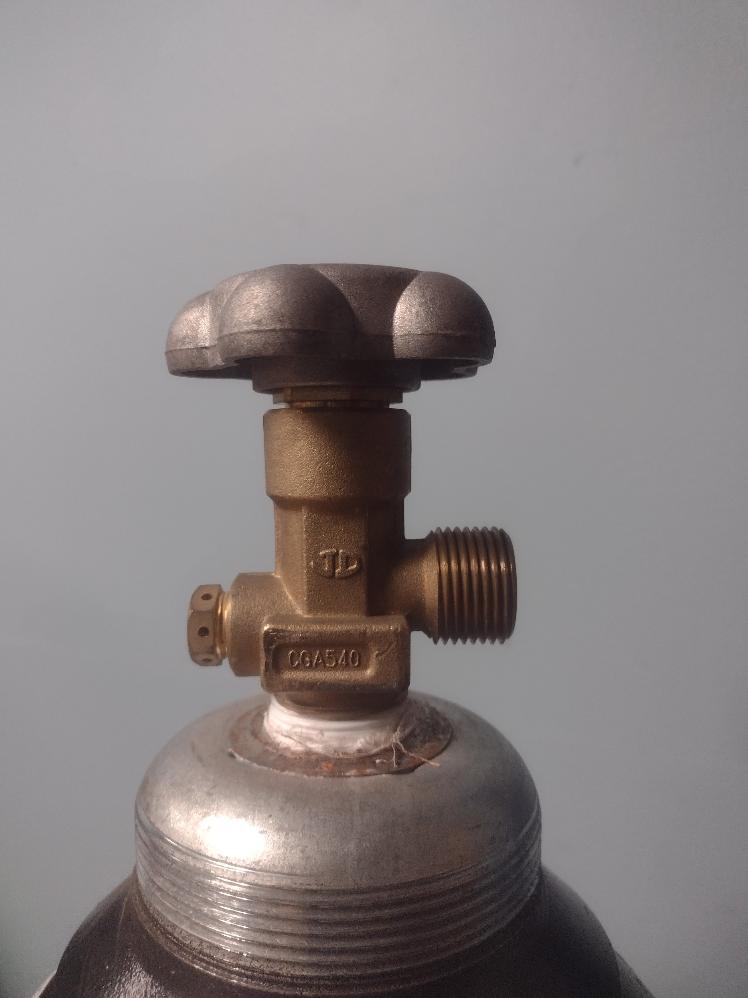
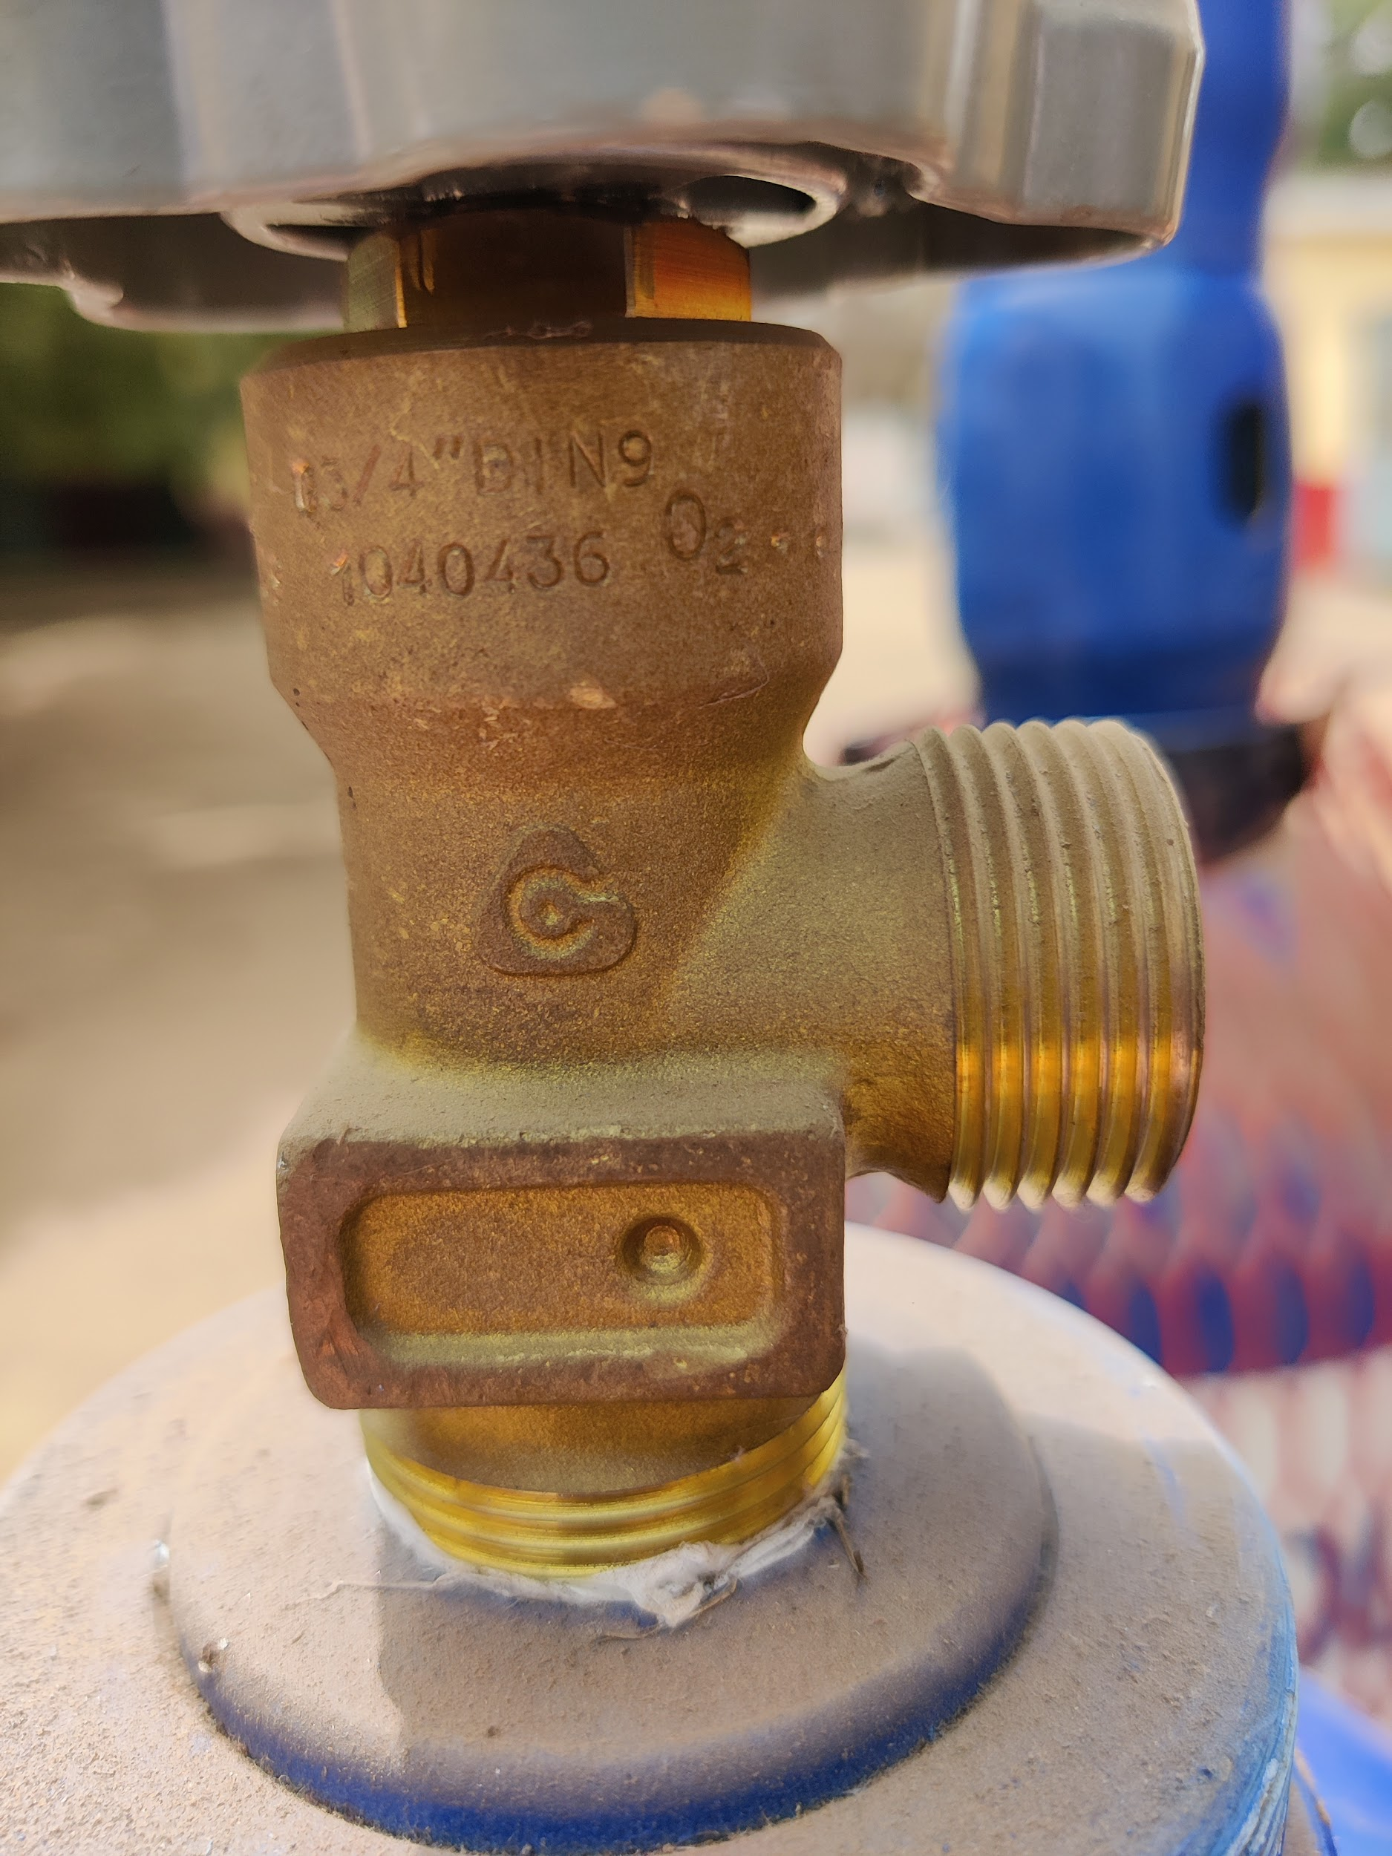
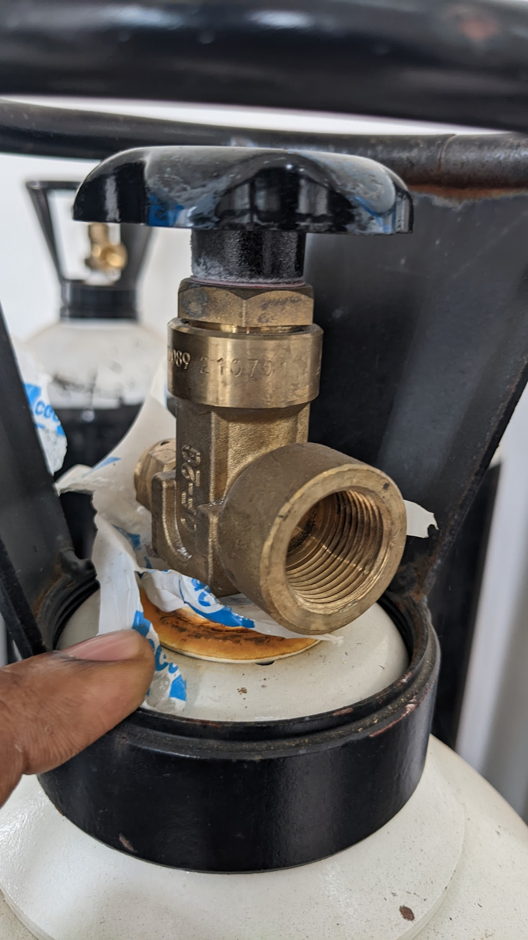
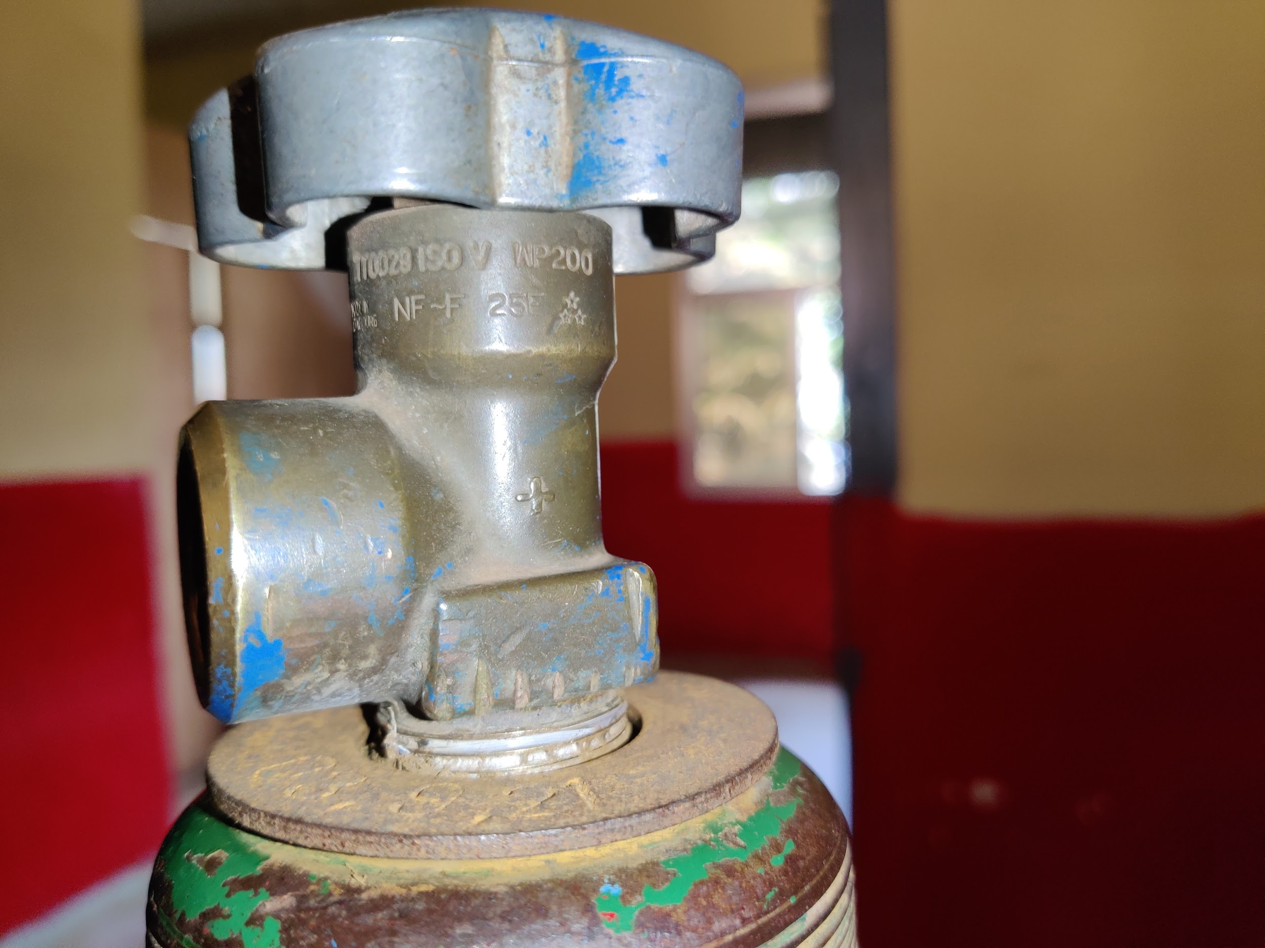
Smaller cylinders often use a pin-index valve. Pin index valves are gas specific like bullnose valves, however they are compatible across different country standards.
Different bullnose valves for oxygen. Despite some looking nearly identical, all of these valves are from different non-compatible standards. Equipment that connects to one valve will not fit on the others valves.
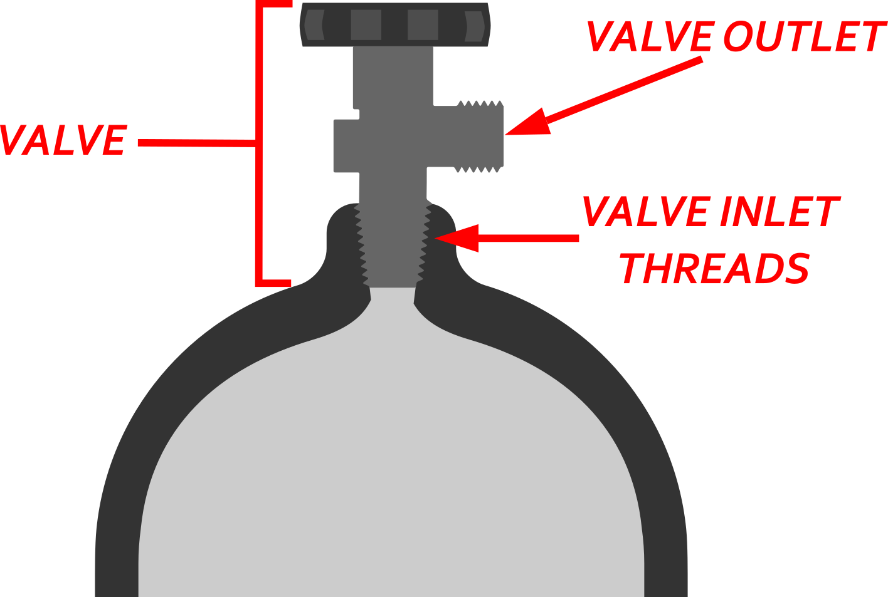
Valve Inlet Threads
Valves are attached to cylinders via threaded connection. These threads are known as the inlet threads. Hospital personnel will not normally need to interact with these threads. The thread type will only be important if your country requires a standard or when valves need to be replaced by a local supplier. The thread specification is stamped into the shoulder of each ISO 9809 cylinder.

Figure 3: Valve diagram

Standards for Cylinders
It is recommended that procurers specify the relevant country standards for compressed gas cylinders when submitting tenders. If standards have not been adopted by your country, it is recommended to specify relevant ISO standards in procurement documents. Below is a brief summary of important ISO standards that apply to medical oxygen cylinders, as well as important details to clarify in tender documents. The standards provided below are not an exhaustive list of all standards relevant to oxygen cylinders, cylinder use or cylinder procurement. A more complete list of standards can be found in the WHO document titled 'WHO-UNICEF Technical Specifications and Guidance for Oxygen Therapy Devices' Table A1.1: Technical Specifications for Oxygen Cylinders. It should be noted that cylinders do not necessarily need to meet all of the noted standards to be acceptable. For example, the cylinder valve threads could be specified by a non ISO standard thread (BSI, CGA, DIN) while still following ISO 9809. Meaning, the exhaustive list of ISO standards provided in the link above does not cover or specify all ISO compliant types of cylinders.

ISO 9809: Gas cylinders — Design, construction and testing of refillable seamless steel gas cylinders and tubes. This standard covers the vast majority of oxygen cylinders in the field (exclusive of aluminum cylinders). The standard has four parts ISO 9809-1,...,4. Most medical gas cylinders in the field fall into part 1 and 3 and may be referred to by the manufacturer as ISO 9809-1 or 9809-3 in bids. The standard specifies tests and inspections that must be carried out by inspector(s) during and after manufacturing. It is important the requirements of the inspector(s) be clarified in the tender. Countries often have requirements on who qualifies as an inspector, and this local standard should be adhered to. If no local requirement or standard is in place, It is recommended that the tender require a mutually agreed upon and independent inspecting agency serves as the inspector in accordance with ISO 9809.

ISO 13769: Gas cylinders — Stamp marking. This standard covers information stamped permanently into the shoulder of the cylinder. The standard specifies places to mark a stamp of the inspection body inspecting the cylinder. As above, we recommend that a mutually agreed upon independent inspecting agency be specified in the bidding.

ISO 32: Gas cylinders for medical use - Marking for identification of content. This standard specifies the color of cylinders based on their gas contents.

ISO 11363 Gas cylinders - Threads. These standards specify two screw threads that connect the valve to the steel cylinder. There are many other standards. There is no recommendation for any specific standard, however the thread type and standard should be clearly stated in the bid document.

Standards Referenced
- ISO 9809-1:2019 , Gas cylinders- Design, construction and testing of refillable seamless steel gas cylinders and tubes- Part 1: Quenched and tempered steel cylinders and tubes with tensile strength less than 1 100 MPa
- ISO 9809-3:2019, Gas cylinders - Design, construction and testing of refillable seamless steel gas cylinders and tubes - Part 3: Normalized steel cylinders and tubes
- ISO 7866:2012, Gas cylinders - Refillable seamless aluminum alloy gas cylinders - Design, construction and testing
- CGA V-1: Standard for Compressed Gas Cylinder Valve Outlet and Inlet Connections
- BS 341-3:2002, Transportable gas containers valves, Part 3: Valve outlet connections
- NF E 29-650 :2020. Gas cylinder - Valve outlet connections for cylinders and bundles
- ISO 13769:2018 - Gas cylinders - Stamp marking
- ISO 32:1977 - Gas cylinders for medical use - Marking for identification of content.
- ISO 11363-1:2018 - Gas cylinders 17E and 25E taper threads for connection of valves to gas cylindersPart 1: Specifications

Appendix A

Determining Cylinder Needs

Units
It is recommended to use consistent units for oxygen in all calculations involving consumption, production, and storage. Additionally, it is recommended to quantify oxygen used, produced, or stored in liters or cubic meters at ambient pressure. It is not advisable to quantify oxygen in terms of "cylinders" as unit of oxygen production, use, or storage because of the wide variety of cylinder sizes and storage pressures used in practice.

Table 1: Unit Conversion Table
 | Liters, L | Cubic Meters, m³ | Cubic Feet, ft³
1 L | 1 | 0.001 | 0.035
1 m³ | 1,000 | 1 | 35
1 ft³ | 28.3 | .0283 | 1

Calculating Cylinder Capacity
Cylinder capacity can be calculated directly by multiplying the water volume (in any unit) of a cylinder by the filling pressure in bar. A similar formula can be used if pressure is given in PSI.

$O_{2 } capacity ≈V_{water} × P$ where P is in units bar
or
$O_{2 } capacity ≈V_{water}×\left(\frac{P}{14.7}\right)$ where P is in units psi

For example, a cylinder with a water volume of 20L filled to 140 bar will have an oxygen capacity of 20 x 140 = 2,800L of stored oxygen.

As demonstrated above, the volume of oxygen stored in the cylinder depends on the filled pressure. If a hospital is filling its own cylinders with a PSA or VSA plant, the filling pressure will be determined by the capabilities and the setpoints of the booster compressor. Otherwise it will be determined by the practices of the supplier. A good rule of thumb is to assume cylinders will be filled to 140 bar. When filling cylinders, care should always be taken not to exceed the working pressure of the cylinder. A common working pressure for oxygen cylinders is 150 bar.

In practice, the entire contents of the cylinder are not often consumed. Supply manifolds with automatic changeover valves may leave around 8-10 bar in the cylinders. Additionally, hospital staff will often change the cylinders that are being used at bedside before they reach 5 to 10 bar. A more conservative estimate for usable oxygen stored in cylinders can be made by calculating the cylinder capacity using a pressure of 10 bar less than the filling pressure. For example, 140 - 10 bar = 130 bar.

This definition should not be not be confused with "filling pressure," which is defined in ISO 10286 and is the maximum pressure at time of filling. Because of heat generated by compression of gas, during filling the cylinder may temporarily be at a pressure slightly above the working pressure. In practice, oxygen booster compressors that fill cylinders from PSA plants fill slowly enough to not raise the pressure to or above working pressure.

