Briefing Note: Compressed Gaseous Oxygen Cylinder Management

Date published: 11 April 2025
This document was developed by Build Health International for the Global Fund’s Project BOXER.

1. Introduction

This document contains key information about managing compressed gaseous oxygen cylinders, including the hazards associated with the presence of oxygen cylinders at hospitals. To mitigate these hazards, PSA plant technicians and managers are encouraged to review the safety measures and considerations regarding how to store, transport and maintain oxygen cylinders. This document also includes recommendations for oxygen cylinder inventory quantities that should be considered if oxygen cylinders are planned to be filled in a new PSA plant.

2. Oxygen Cylinder Hazards

Oxygen cylinders require careful management due to the risks they pose. Without safe management, there is considerable risk of fire, injury or death. The presence of medical oxygen increases the risk of fire. COVID-19 has highlighted the lack of oxygen in many settings and influenced a large influx in medical oxygen access. With more access to medical oxygen comes more risk in hospital settings, especially if the hazards of oxygen cylinders are not well known.
- Fire: Oxygen cylinders must be kept far from open flames and areas where hospital visitors may smoke. Oxygen cylinders cannot come into contact with substances that would fuel a fire, such as oil, grease, or solvents like alcohol or hand sanitizer. High-purity oxygen in the presence of a flame creates a chain reaction that produces a hotter flame and allows that flame to consume more fuel.
- Risk of Projectile Force: Oxygen cylinders store oxygen at high pressures. The compressed gas contains significant energy. Damage to the body and especially the valve of the cylinder can lead to an uncontrolled release of the energy that poses a risk of severe injury or death to persons near the cylinder. Cylinder valves can be easily damaged if a cylinder falls over. The escaping gas can accelerate the cylinder turning it into a projectile. Such damaged cylinders have enough force to pass through multiple walls and can pose a serious risk of injury or death to any person in its path.
- Falling Cylinders: Oxygen cylinders are heavy and can fall when not secured properly. While falling cylinders are at risk of exploding, they are also at risk of falling on patients or into neonatal incubators.


3. Oxygen Cylinder Safety

How to reduce the risk of fire:
- Ensure adequate ventilation to limit oxygen accumulation. For example:
  - Open doors before starting the plant.
  - Use exhaust fans for airflow.
  - Inspect for and address leakages.
  - Only use equipment as intended.
- Never allow fuel sources to accumulate in the oxygen plant. For example, stacks of paper, bird’s nests, gasoline, clothes, rags, and wood from in and around the oxygen plant house and cylinder storage space should be removed.
- Never allow heat sources like stoves, grills, heaters, matches, welding equipment, cars, motorcycles, smoking, or overloaded power strips near the oxygen equipment.
- Ensure the oxygen plant is a clean, safe space by keeping the plant free of clutter and checking that all filters and exhaust fans are working properly.
- Keep any equipment that could spark away from sources of oxygen. Short-circuiting and overheating electronics are one of the leading causes of oxygen-related hospital fires. Ensure that electrical infrastructure is well maintained.
- In cold regions – Do not use personal heaters, radiators, and steam pipes in close proximity to oxygen. Do not have fires near sources of oxygen.
- In hot regions – Pay close attention to portable or wall-mounted air conditions and fans that can short circuit, spark, ignite, and cause a fire.

How to reduce the risk of falling cylinders and explosions:
- Secure cylinders and containers with a chain, strap, rack or other suitable device. Do not use extension cords, clothing belts, etc.
- Use valve protection for cylinders not in use.
- Do not drag, drop, or roll cylinders, nor lift cylinders by the valve protection.
- Store and use the cylinder with the valve facing up to ensure proper operation of the valve and relief devices.
- Use non-abrasive strapping to secure composite cylinders.
- Never force connections that do not fit. Use of adaptors or incorrect valve outlets can result in dangerous connections leading to injury/death, equipment damage, or uncontrolled product release.
- When connecting equipment, point the valve outlet away from personnel, and open the valve slowly.

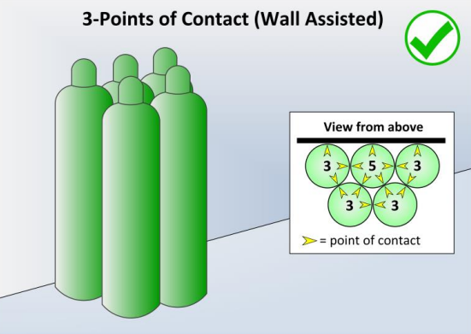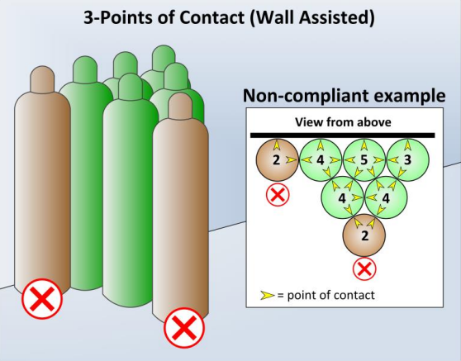
Figure 1: Three Points of Contact (Wall Assisted)* Figure 2: Three Points of Contact (Wall Assisted)*
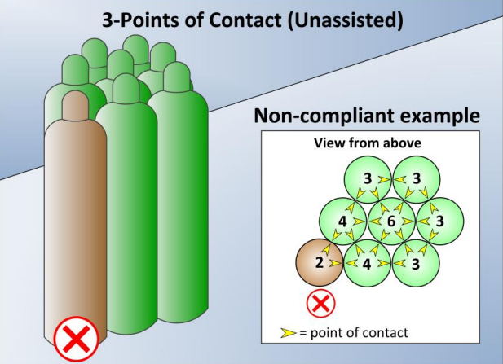
Figure 3: Three Points of Contact (Unassisted)* Figure 4: Three Points of Contact (Unassisted)*
*https://osha.oregon.gov/OSHARules/pd/pd-186.pdf

How to keep cylinder valves clean
- Keep valve caps on valves when the cylinders are not in use
- If available use oil-free compressed air or another inert gas to blow out dust and debris
- A lint free cloth or soft bristle brush can also be used to gently wipe out the valve openings and dislodge visible particles, taking care to prevent debris from scratching or embedding into the valve
- It is common practice to briefly open the cylinder valve, and allow the compressed oxygen to clear away any potential debris before closing the valve again and connecting it to the manifold or regulator. If this activity is done, the following must be considered:
  - Open the valve very slowly and very slightly
  - Stand to the side of the opening valve
  - Point the valve away from all people
  - The surrounding area must be well ventilated
- After cleaning, reinspect the valve. If there is still debris remaining in the valve after the above activities have been performed, the cylinder should be removed from service to allow for the valve to undergo a more comprehensive deep cleaning. This deep cleaning must be performed by a qualified professional and typically entails removing the valve from the cylinder, cleaning it in an oxygen safe solution according to industry standards, and reattaching the valve to the cylinder body.

4. Oxygen Cylinder Storage

- Cylinders must be secured in an upright position, regardless of whether they are in use or in storage.
- Cylinders should clearly identify if they are full or empty. This can be accomplished through an integral pressure gauge or signage.
- Safety caps should remain on cylinders at all times when not in use.
- When multiple cylinders are grouped together, it is recommended that cylinders be secured by nesting so that they have three points of contact. Nested cylinders will still require chains or straps to secure them.
- Cylinders should be placed only on flat floors or platforms.

5. Oxygen Cylinder Transportation

Ground transport
- When moving cylinders, make sure valves are closed, valve protection is in place, the cylinder is properly secured, and moved in the upright, valve-up position. Inspect for cracks, leaks, and dents.
- Cylinder dollies or other mechanical lifting devices should be used to move the cylinders. Secure cylinders in a cylinder cart with a chain and move to a new location. Use platforms or cradles that keep cylinders upright and secured when lifting with mechanical equipment. Only one cylinder should be handled at a time except on carts designed to transport more than one cylinder.
- Avoid dropping, rolling, or dragging cylinders. Do not let the cylinders fall or bang into anything. Do not lift cylinders by valve protection cap. Protect from excessive heat. These best practices reduce the risk of explosions or the release of gas.
- Secure cylinders in an upright, valve-up position at all times to prevent movement as they should not be allowed to shift relative to each other or the supporting structure.

Vehicle transport
- For vehicle transport, it is preferable to use an open vehicle or trailer, as well as transporting the cylinders in an upright position. Alternatively, store cylinders in a separate compartment from the driver or sit near a partially open window to prevent oxygen and heat from building up in the vehicle.
- Secure the cylinders in the vehicle or trailer to prevent movement during transit. Cylinders should not be allowed to shift relative to each other or the supporting structure.
- Vehicles should include appropriate signage with hazard statements, signal words, and pictograms in accordance with local regulations for the transport of flammable compressed gas.

General transport best practices:
- Personal protective equipment, such as eye and hand protection, should be worn when handling oxygen cylinders.
- It is recommended that cylinder caps be used for safety, when available.
- Use appropriate transportation equipment (e.g, cylinder trolley).

6. Oxygen Cylinder Inventory

Cylinder inventory requirements will be based on oxygen consumption at all facilities being supported by the oxygen plant. Principal Recipients are encouraged to
- Calculate how many oxygen cylinders are needed per week or per month across all facilities.
- Determine how many cylinders need to be filled per day to meet those needs.

Build Health International (BHI) recommends having a cylinder inventory of at least three times the number of cylinders that will be filled by the oxygen plant in a day. The three-times cylinder inventory is recommended to ensure there are ample cylinders available to be filled, to be used, and to be transported simultaneously. If there are plans for expansion or to increase oxygen consumption for any reason, implementers should consider calculating cylinders needs based on future consumption. Adequate storage space for all empty and full cylinders should be considered.

