Briefing Note: Energy Product Guidance

Date published: 28 March 2024
This document was developed by Build Health International for the Global Fund’s Project BOXER.

The purpose of this document is to provide guidance on the purchase of energy products to support the installation of oxygen plants.

1. Generators

Build Health International (BHI) recommends purchasing generators from companies that can ensure the following essential criteria:
- Good warranty on products.
- Accessible and available spare parts.
- Available and responsive technical support.

International manufacturers
International manufacturers can typically provide good quality products with a warranty, spare parts and technical support. Purchasing from large, international companies comes at a higher price point than smaller regional manufacturers. However, if your capacity to do due diligence on a generator tender process is limited, it is worth spending more to know with reasonable certainty what you will be getting. Some examples of international manufacturers of generators are pictured below (Figure 1):


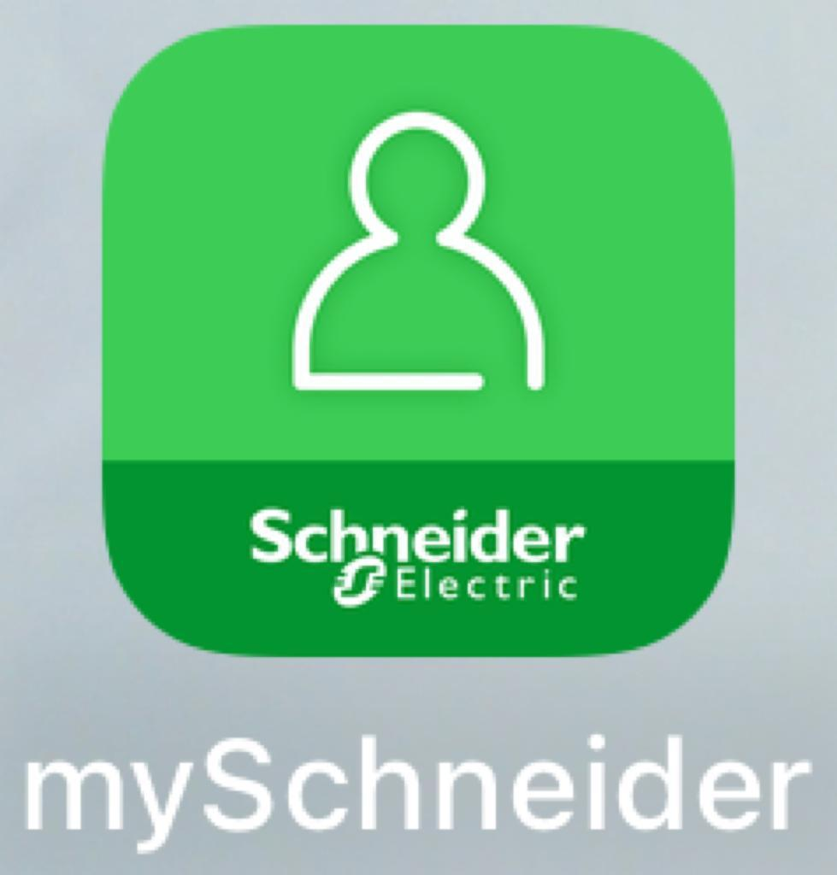
Figure 1: International manufacturers of generators

Regional manufacturers
Many mid-sized regional manufacturers also provide excellent quality generators, along with strong technical support, spare parts and a warranty. These manufacturers often have more competitive costs than international manufacturers, are more responsive to customers in providing technical support, and are more flexible in designing generator set specifications that can meet the needs of PSA plants. Due diligence is important when selecting a regional manufacturer to ensure that the three essential criteria outlined above are met, quality is good and specifications of the generator will meet the needs of the PSA plant. One example of a regional manufacturer is pictured below (Figure 2):

Figure 2: Example of regional manufacturer


Generator engines

A generator with an internationally recognizable and reliable engine brand, such as Perkins, does not necessarily mean that the generator is of good quality. The generator should be evaluated by a qualified technician to ensure that it meets the specifications required to support the facility load and is manufactured by a company that meets the three essential criteria outlined above (accessible and available spare parts, strong technical support, and a good warranty). It is helpful to have an engine from an international manufacturer, such as Perkins (Figure 3), due to overall global accessibility and availability of parts, and the fact that most technicians will be familiar with them.

Figure 3: Example of international engine manufacturer

2. Cable

Cables are typically produced to international (harmonized) codes and/or national codes. BHI recommends using cables that ideally meet international codes (e.g., IEC, BS, EN, NFPA) or at least national codes and are sourced from reliable vendors. Usually, countries have their own trusted cable manufacturers, but there are always counterfeits in the market that are unsafe. Recognizing counterfeits from authentic cables can be challenging and requires trained eyes. Cable specifications, including sometimes the standards in which they were made, are visible (printed) on the jacket of the cable (see Figure 4). Additional information should be provided on the manufacturers’ websites. Cables should be easily identified by the label on their jacket. An unexpectedly low price point is a good indicator for counterfeits. To ensure authenticity, it is recommended that you check the make and model are listed on the cable jacket, and cross check them on the manufacturer website. In many countries, high voltage cables will need to be imported.

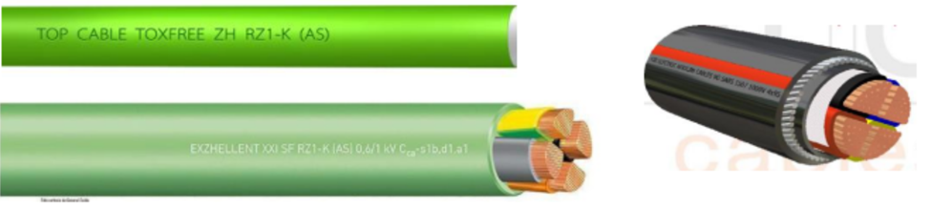
Figure 4: Examples of Cables

3. Switchgear

Circuit breakers
It is important to invest in good quality switchgear to avoid breakers that fail. Failed breakers will stop the flow of electricity and potentially burn, melt, and cause a fire. This can happen when breakers have low-quality conductor material, contact, and/or insulation material. Additionally, low-quality breakers may provide a false sense of security by failing to provide the required overcurrent protection.

Copper busbars
BHI recommends using international brand standards for busbar enclosures, when possible. Cabinets need to be properly constructed enclosures, well protected, and sufficiently secured. It is critical to use high quality materials for electrical cabinet construction as well. When using locally made enclosures, it is important to use reputable contractors that will build them to meet the minimum international standards outlined below. Examples of both poorly constructed enclosures (Figure 5) and well constructed enclosures (Figure 6) are shown below. Internationally recognized brands are shown below in Figure 7.

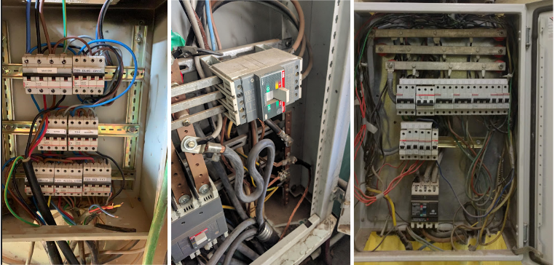
Figure 5: Poorly constructed enclosure examples from BHI’s work

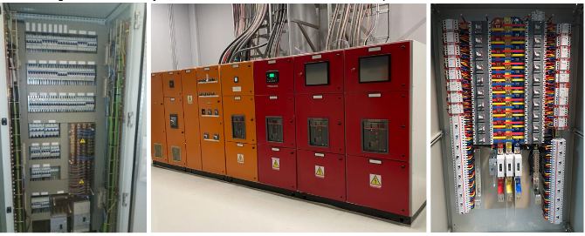

Figure 6: Well-constructed enclosure examples from BHI’s work



Figure 7: Internationally recognized brands which produce switchgear products

Product authenticity
Due to the many counterfeit products on the market, it is important to ensure only authentic products are purchased. Some products have applications you can download onto a phone or tablet that allow you to scan the QR code on the product. If the specifications on the product you want match the specifications that appear on the application when the QR code is scanned, the product is likely authentic (although, not guaranteed). For example, for a 30mA labeled RCCB, you would expect the specification that appears on the application when the QR code is scanned to also indicate 30mA. Another way to distinguish between authentic and counterfeit products is by cost. Cheaper products are more likely counterfeit although costs and availability of authentic products will vary by country.

4. Power Electronics

UPS Systems
Switchgear should only be purchased from reputable brands/suppliers. In the same way as with generators, suppliers must be able to guarantee after sales service and spare parts availability. When battery expansions are required, only manufacturer approved batteries should be used. Installation requirements and ambient conditions recommended by manufacturers should always be followed. See Figure 8 for examples of internationally recognized brands which produce UPS systems.



Figure 8: Internationally recognized brands which produce UPS systems

Automatic voltage regulators
When purchasing an automatic voltage regulator (AVR), it is important to confirm that the manufacturer can ensure the following essential criteria:

- Good warranty with proper documentation.
- Official manuals.
- Technical support available from the manufacturer.
- An official website to verify all this information is legitimate.
It is important to properly size your AVR for the PSA plant rating and requirements. It may even be necessary to oversize the AVR. BHI recommends that you consult a qualified technician to assist with AVR sizing.
The price differences between quality AVRs and poor quality AVRs is very high. It is worth spending more money to ensure the manufacturer provides all the essential criteria listed above. Decent alternatives to international brand AVRs, which are at the highest price point, may be available on the market but if they do not meet the four essential criteria listed above, they are not good options. See examples of internationally recognized brands that produce AVRs in Figure 9.
The due diligence process in purchasing an AVR starts with having a reputable vendor. It is widely known that most AVRs are produced in Eastern Europe. We encourage you to look up online where the AVR brand you are purchasing is from, and check if that matches the country origin factory on the AVR. This will help to ensure you are paying for an authentic product.

Voltage stabilizers should be utilized when the primary power source for the PSA plant is not 100% generator. For example, a voltage stabilizer is necessary if the PSA plant is connected to city power or both city power and generator. If power quality is good enough to ensure stable PSA plant operation, AVR might not be critical.

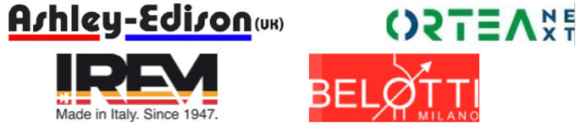

Figure 9: Internationally recognized brands that produce AVRs

