Briefing Note: PSA Plant Location
Considering Pollution

Date: July 9 2024

BHI recommends installing a PSA plant at least 10m away from any possible source of pollution. This includes but is not limited to generator exhaust, vacuum system discharges, vehicular exhaust, and incinerator exhaust. This recommendation is based on the guidance from various PSA plant manufacturers and is in line with the standards listed below. While only the NFPA 99 lists a specific distance (7.6 m) between pollution sources and a PSA plant, the intention of all three standard excerpts is to ensure the PSA intake is clean air. To guarantee this, distance from a pollution source should be considered among other factors including exhaust direction and prevailing winds.

NFPA 99
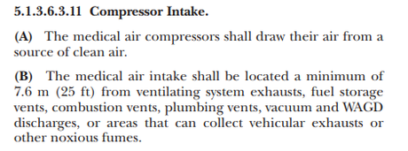

HTM-02
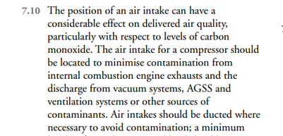

ISO 7396
