Overview: PSA Plant Maintenance Tool Kit Inventory

Date published: 25 April 2025

Introduction

An appropriate set of tools and safety equipment is essential for the maintenance and operation of a pressure swing adsorption (PSA) oxygen plant and the attendant oxygen delivery system. These tools are required for the hospital technicians and operations staff to effectively and safely perform the required daily maintenance, routine maintenance, basic troubleshooting, and predictable repairs. The tools presented in the table below represent a set of tools that are most frequently needed for the required service of PSA plants. This tool kit was assembled with multiple common tool sizes and types, allowing for it to be used as a kit that can service a wide variety of PSA plants and oxygen delivery systems. This tool kit should be used exclusively for the oxygen system and should be kept free of grease and dirt at all times.

Both tool kits should be used exclusively for the oxygen system and should be kept free of grease and dirt at all times. Vacuum swing adsorption (VSA) and vacuum pressure swing adsorption (VPSA) plants may require additional or different tools. The list below is a general tool kit list for PSA plants only.

Please note: This tool kit has not been developed or endorsed by any specific supplier. It is based entirely on BHI's experience servicing and assessing PSA plant equipment. Additional tools may be required to perform specific service interventions, and all service must be performed in adherence with the manufacturers requirements.

Local Availability Legend
Color | Availability
 | Limited anticipated issues sourcing these items from local vendors.
 | Some issues expected when sourcing these items from local vendors. Items may be available but do not meet safety or sizing requirements.
 | Significant difficulty is expected when sourcing these items from local vendors.

General Tool Kit

# | Item Description | Qty | Photo | Requirement / Alternatives | Tool Purpose
1 | SAE/Metric Folding Hex Key Set (3-Piece) | 1 | 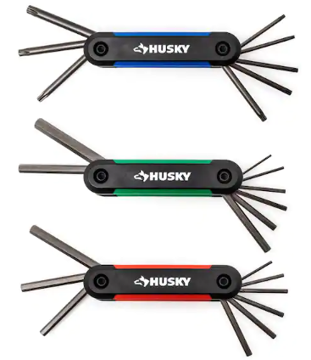 | Needs metric and SAE (imperial) sizes up to 10mm/3/8" | Used to turn bolts or screws with hexagonal sockets to access PSA plant equipment for internal maintenance or repair. Also known as “Hex keys”.
2 | Cushion-Grip Adjustable Wrench, Chrome Plated, 8" | 1 | 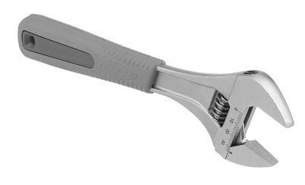 | Minimum 1"/25mm jaw capacity | Used to turn or loosen nuts and bolts for access to PSA plant equipment for internal maintenance or repair.
3 | Zippered Tool Bag with pockets | 1 | 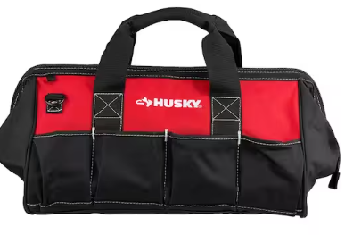 | Approximately 18in. | Used to hold all tools and keep them organized.
4 | Clamp meter with phase rotation meter | 1 | 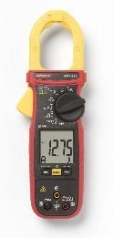 |  | Important electrical diagnostic tool for equipment troubleshooting or confirming completed electrical works.
5 | Infrared Thermometer Non-Contact Digital Laser Temperature Gun | 1 | 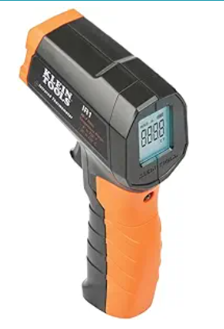 |  | Non-contact thermometer used for troubleshooting overheating equipment.  - Non-contact infrared Thermometer (does not need to be medical grade)  - Temperature Range: -50 to 400 degC  - Temperature Accuracy +/- 4 degC
# | Item Description | Qty | Photo | Requirement / Alternatives | Tool Purpose
6 | Ultrasonic digital oxygen analyzer | 1 | 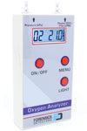 | Ensure the charger is compatible with the local outlet type, or order the necessary adapter. | Handheld oxygen analyzer used for daily checks of oxygen purity.  - Oxygen (O2) Range: 21% - 95% (Error < ± 1.0% of O2)  - Oxygen (O2) Range: 96% - 100% (Error < ± 3.0 % of O2)  - O2 flow range: 0 - 10 LPM (< ±0.2 LPM)  - O2 pressure range: 0 - 199 kPa ( < ± 2 kPa)  - Recovery / response time: < 30 seconds  - Storage / operating temperature: 40F - 130F  - Storage / operating humidity: < 95% RH  *BHI recommends ultrasonic handheld analyzers. If a galvanic cell sensor is procured it should be replaced yearly.
7 | Screwdriver Set, 1000-Volt Insulated (6-Piece) | 1 | 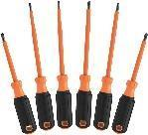 | Insulated for protection against electric shock. | Used to insert or remove screws to access PSA Plant equipment for internal maintenance or repair.
8 | Ratcheting Combination Wrench Set, SAE/MM (10-Piece) | 1 | 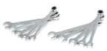 |  | Used to tighten or loosen PSA plant equipment fasteners for internal repairs and maintenance.
9 | Strap wrench | 1 | 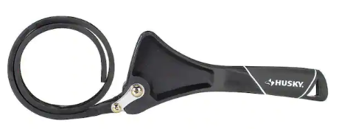 | For replacing oil filters. Not needed for VSA or VPSA plants. | Used to replace oil filters in the PSA plant without damaging the filters.
10 | Safety Ear Muffs | 2 | 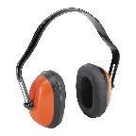 | Access to disposable ear plugs is an acceptable alternative. | Personal protective equipment (PPE) that protects technicians’ hearing from loud PSA equipment.
# | Item Description | Qty | Photo | Requirement / Alternatives | Tool Purpose
11 | Safety Glasses with Clear Lenses, Meets ANSI Z87.1 Standards | 2 | 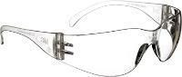 |  | PPE that protects technician’s eyes from equipment debris during repairs or maintenance.
12 | Safety Work Gloves, Seamless Knit Nylon Glove with Coated Black Micro-Foam Nitrile Grip,Ideal for General Purpose | 3 | 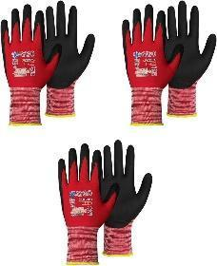 |  | PPE that protects technicians’ hands during repairs or maintenance.
13 | 1/4 in. and 3/8 in. Metric and SAE Drive Socket Set (34-Piece) with ratchet | 1 | 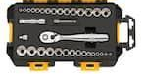 |  | Used to tighten or loosen PSA plant equipment fasteners for internal repairs and maintenance.
14 | 3/8-Inch Drive Click Torque Wrench (5-80 ft.-lb.) | 1 | 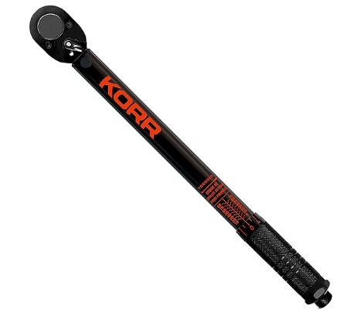 |  | Used to tighten nuts and bolts to a specific intensity. This avoids over or under tightening, and keeps pressure equal.
15 | High-Performance, Water Resistant Headlamp | 1 | 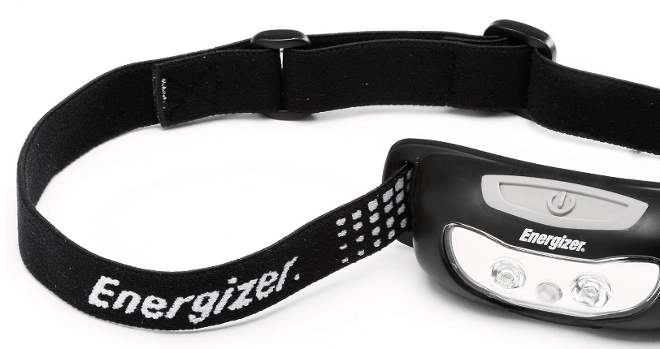 |  | Used to illuminate inside of a compressor.
16 | Retracting-Blade Utility Knife | 1 | 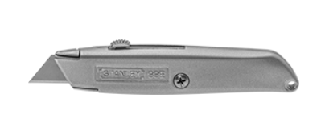 |  | Used for opening spare parts packages.
17 | 1000V 6-Piece Mini Insulated Screwdriver Set | 1 | 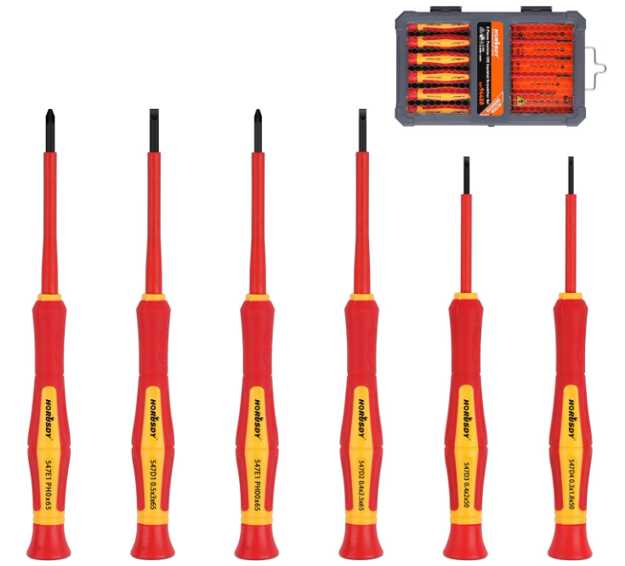 |  | Used for small electronics.
# | Item Description | Qty | Photo | Requirement / Alternatives | Tool Purpose
18 | Plug adapter for the oxygen analyzer | 1 | 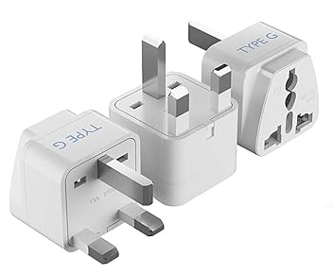 |  | Plug adapter type will vary by country.
19 | 16 Oz Plastic Spray Bottle | 1 | 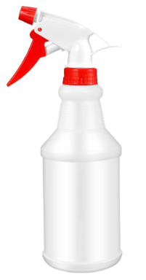 |  | Empty spray bottle

