PSA Plant Maintenance Tool Kit Inventory: Booster Compressors

Date published: 25 April 2025

Introduction

Please note: These tool kits have not been developed or endorsed by any of the mentioned suppliers and are based entirely on Build Health International’s experience servicing and assessing this equipment. Additional tools may be required to perform specific service interventions, and all service must be performed in adherence with the manufacturers requirements.

Oxygen Booster Compressor Tool Kit (Rix Industries and ULTRACECO): This tool kit is specific to Rix Industries brand compressors (models 2PS and 2V3B) and ULTRACECO (HP models). These tools are required for the plant operator to effectively service and/or troubleshoot the Rix / ULTRACECO compressor.

Oxygen Booster Compressor Tool Kit (NOVAIR and Noxerior): This tool kit is specific to NOVAIR brand HP series and Noxerior compressors. These tools are required for the plant operator to effectively service and/or troubleshoot the NOVAIR / Noxerior compressor.

Oxygen Booster Compressor Tool Kit (Bailian and ULTRACECO): This tool kit is specific to Bailian brand compressors (including GOW-3/4-150, GOW 15/4-150, and other similar models) and ULTRACECO (HPX models). These tools are required for the plant operator to effectively service and/or troubleshoot the Bailian / ULTRACECO compressor.

Oxygen Booster Compressor Tool Kit (Anshan Jiapeng): This tool kit is specific to Anshan Jiapeng brand compressors. These tools are required for the plant operator to effectively service and/or troubleshoot the Anshan Jiapeng compressor.

All tool kits should be used exclusively for the oxygen system and should be kept free of grease and dirt at all times.

Local Availability Legend
Color | Availability
 | Limited anticipated issues sourcing these items from local vendors
 | Some issues expected when sourcing these items from local vendors. Items may be available but do not meet safety or sizing requirements.
 | Significant difficulty is expected when sourcing these items from local vendors.

Oxygen booster compressor tool kit: Rix Industries and ULTRACECO
[Applicable to models 2PS and 2V3B and HP models]

# | Item Description | Qty | Photo | Requirements / Alternatives | Tool Purpose
1 | 3/8 Inch Drive x 1/2 Inch Deep 6-Point Socket | 1 | 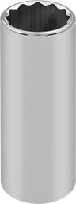 |  | Used to tighten or loosen PSA plant equipment fasteners for internal repairs and maintenance
2 | Plastic Non Marring Pick with Blunt Tip | 1 | 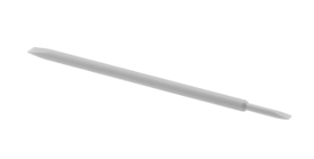 | This tool is typically used for laptop and smartphone repair. | Used to push out the piston, reed valves, or other metal pieces without causing scratches.
3 | 3/8-Inch Drive Click Torque Wrench (5-80 ft.-lb.) | 1 | 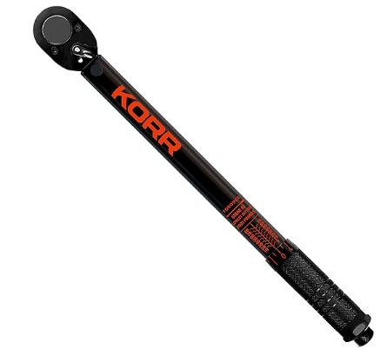 |  | Used to tighten nuts and bolts to a specific intensity. This avoids over or under tightening, and keeps pressure equal.
4 | Deep Socket, SAE, 3/8-Inch Drive, 9/16-Inch, 6-Point | 1 |  |  | Used to tighten or loosen PSA plant equipment fasteners for internal repairs and maintenance
5 | 1/2-inch Combination Wrench, 12 Point, SAE | 2 | 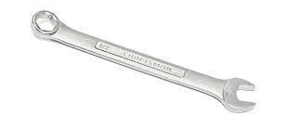 |  | Used to turn or loosen nuts and bolts for access to PSA Plant equipment for internal maintenance or repair
6 | 5/32" allen key T handle | 1 | 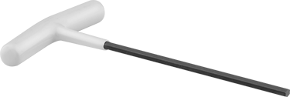 | T-handle, not a kit | Used for tightening and loosening hexagonal bolts
7 | 5/64 allen key T handle | 1 |  | T-handle, not a kit | Used for tightening and loosening hexagonal bolts
# | Item Description | Qty | Photo | Requirements / Alternatives | Tool Purpose
8 | High Precision Stainless Steel Lab Tweezers | 1 | 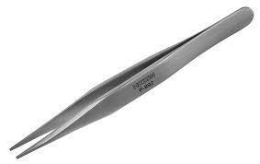 |  | Used for small precision movements and grabbing while doing maintenance inside of the booster compressor.
9 | Pick with 45 Degree Angle Tip and Straight Handle | 1 | 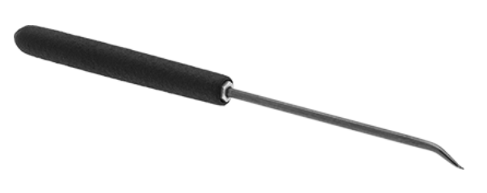 | 45 degree angle | Used for small precision movements; specifically removing ryder and compression rings.
10 | 9/16" x 11/16" Open End Wrench | 1 | 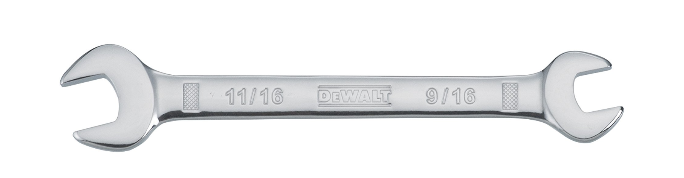 |  | Used to turn or loosen nuts and bolts for access to PSA Plant equipment for internal maintenance or repair
11 | Wipes | 1 |  | Should be lint free. | Used to create a clean oxygen safe working environment. Also to wipe down dirty equipment.
12 | Painters tape | 1 |  |  | Used for keeping open ends of piping & hoses protected from debris entering.
13 | Synthetic lubricant grease (2 fl oz) | 1 | 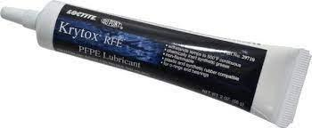 | Krytox or generic brand with equivalent specifications | Primarily lubricates o-rings; causes them to stay in place and seals from air passing.
14 | Nitrile Gloves | 1 |  |  | Personal Protective Equipment (PPE). Protects technicians’ hands and keeps Oxygen Cleaned parts & tools oil free.
15 | Zippered Tool Bag with pockets | 1 |  | Approximately 18in. | Used to hold all tools and keep them organized and accounted for
# | Item Description | Qty | Photo | Requirements / Alternatives | Tool Purpose
16 | Flat head screwdriver | 1 | 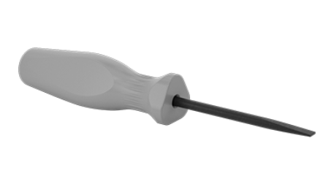 | For 2V3B | Used to insert or remove screws to access PSA Plant equipment for internal maintenance or repair
17 | Phillips head screwdriver | 1 | 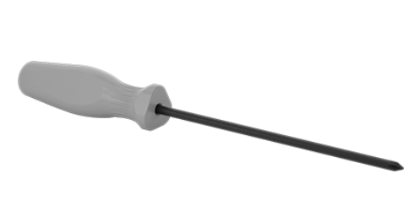 | No. 1 | Used to insert or remove screws to access PSA Plant equipment for internal maintenance or repair
18 | 7/16" Combination Wrench | 1 | 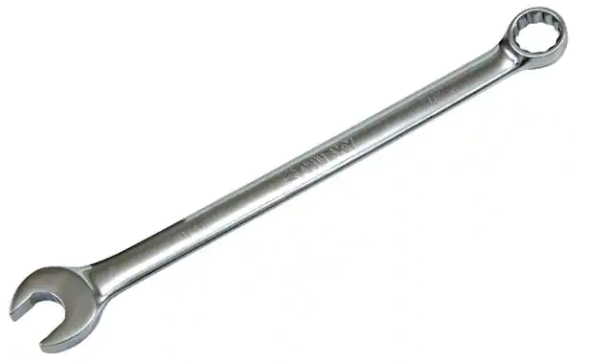 |  | Used to turn or loosen nuts and bolts for access to PSA Plant equipment for internal maintenance or repair
Additional tools required for maintenance that should be provided with the booster compressor by the manufacturer.
19 | Piston adjustment tool | 1 | 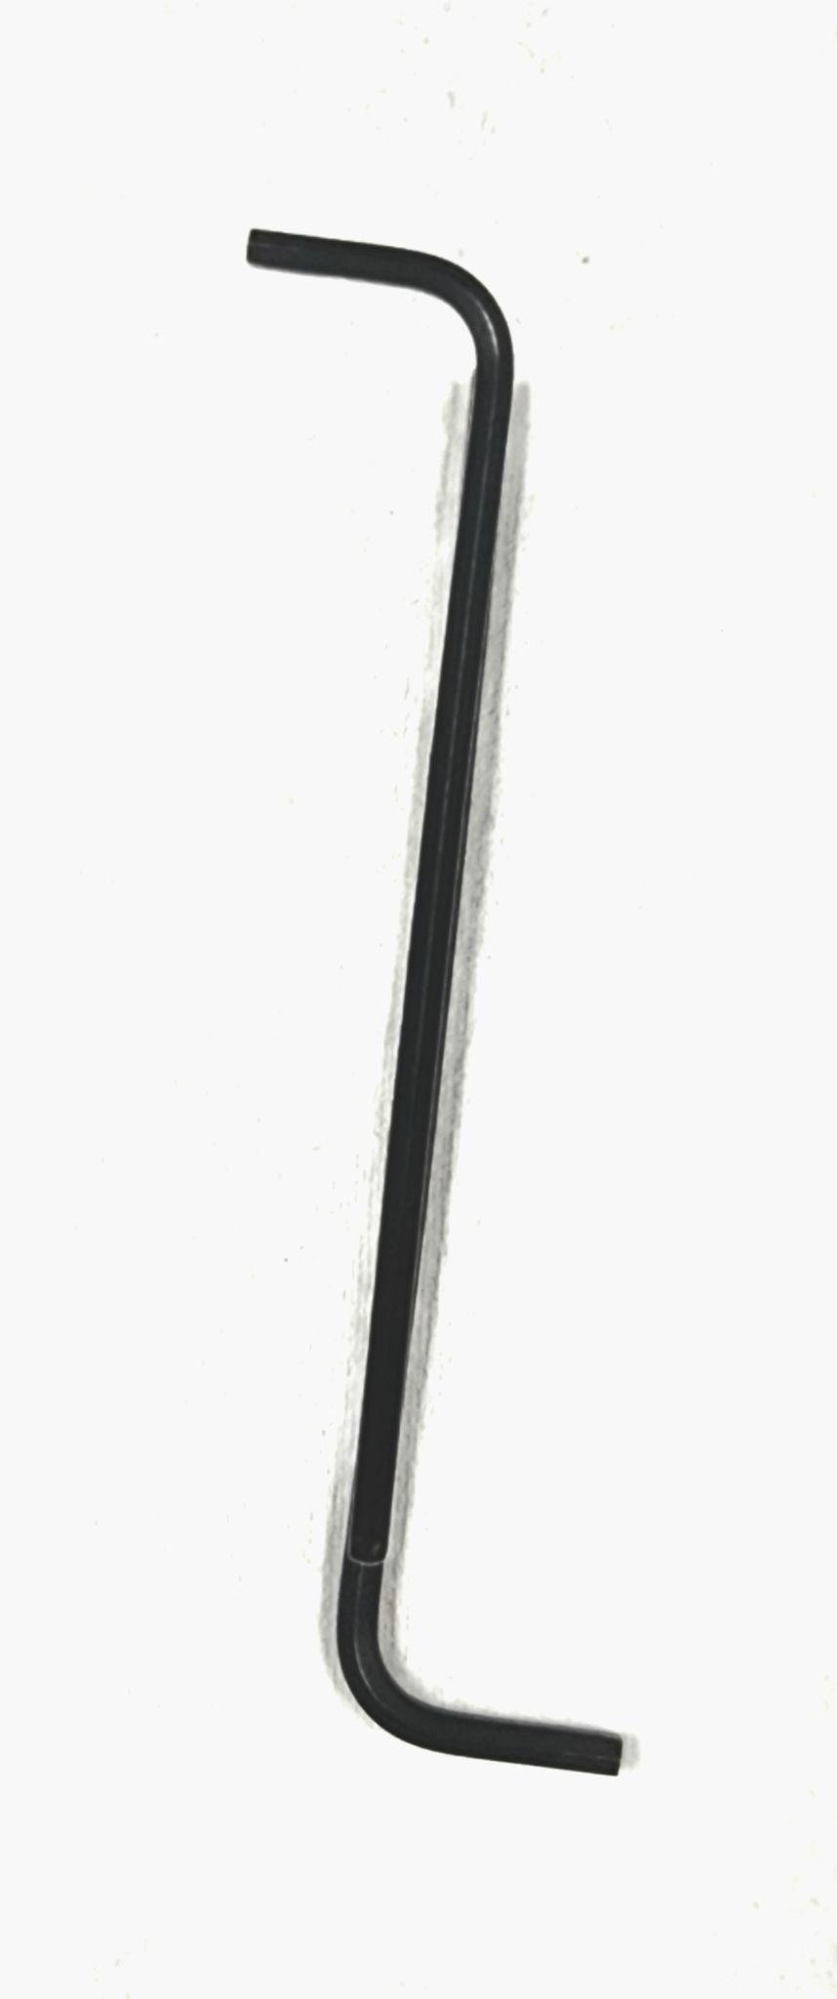 | #88-A8037. Must be procured from manufacturer | For setting the piston height
20 | Sleeve Tool, 3rd Stage, 2V3B | 1 | 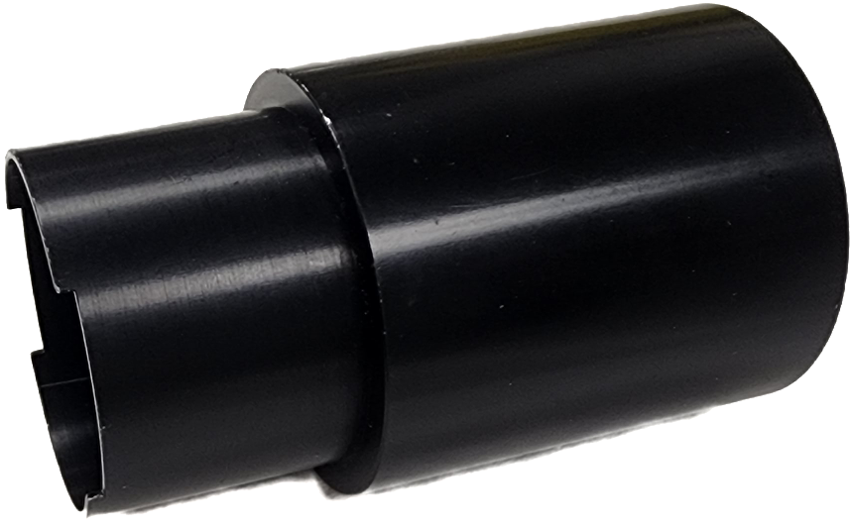 | #X63-C1148-5. Must be procured from manufacturer
21 | Sleeve Tool, 2nd Stage, 2V3B | 1 | 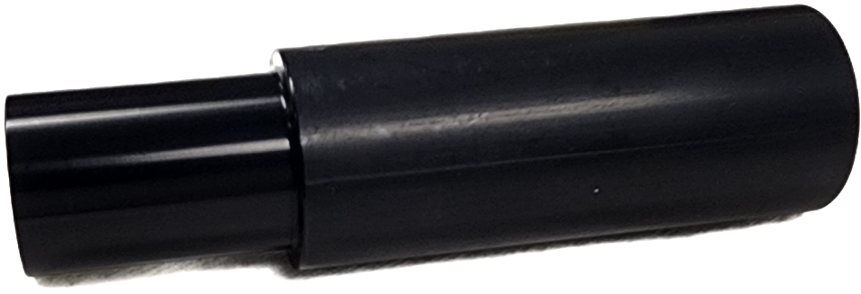 | #X63-A10773. Must be procured from manufacturer
22 | Sleeve Tool, 2nd stage, 2PS | 1 |  | #X63-A5549. Must be procured from manufacturer

Oxygen booster compressor tool kit: NOVAIR and Noxerior
[Applicable to all models in the HP series and Noxerior models]

# | Item Description | Qty | Photo | Requirements / Alternatives | Tool Purpose
1 | Combination wrench, 10 mm | 1 | 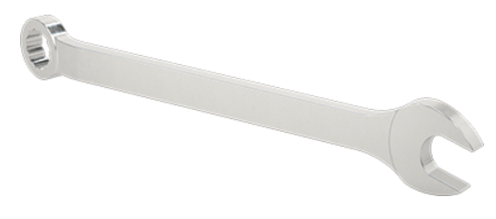 | metric | Used to turn or loosen nuts and bolts for access to PSA Plant equipment for internal maintenance or repair
2 | Combination wrench, 14 mm | 1 |  | metric | Used to turn or loosen nuts and bolts for access to PSA Plant equipment for internal maintenance or repair
3 | Combination wrench, 17 mm | 1 |  | metric | Used to turn or loosen nuts and bolts for access to PSA Plant equipment for internal maintenance or repair
4 | Combination wrench, 19 mm | 1 |  | metric | Used to turn or loosen nuts and bolts for access to PSA Plant equipment for internal maintenance or repair
5 | SAE/Metric Folding Hex Key Set (3-Piece) | 1 | 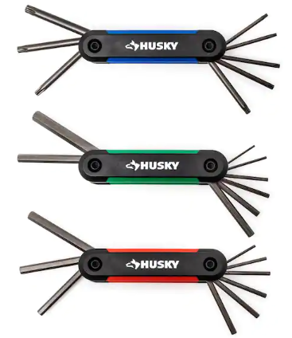 | metric and SAE | Used to turn bolts or screws with hexagonal sockets to access PSA plant equipment for internal maintenance or repair. Also known as “Hex keys”
6 | Plastic Non Marring Pick with Blunt Tip | 1 |  |  | Used to push out the piston, reed valves, or other metal pieces without causing scratches.
7 | 3/8-Inch Drive Click Torque Wrench (5-80 ft.-lb.) | 1 |  |  | Used to tighten nuts and bolts to a specific intensity. This avoids over or under tightening, and keeps pressure equal.
# | Item Description | Qty | Photo | Requirements / Alternatives | Tool Purpose
8 | Thread locking paste | 1 | 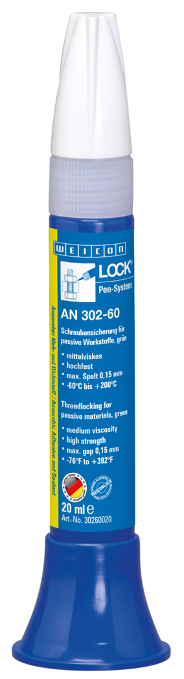 | Weicon lock AN 302-60 or alternative with equivalent properties: nonflammable and temperature limit of 150C or higher | An adhesive, applied to the threads of fasteners such as screws and bolts to prevent loosening, leakage, and corrosion.
9 | Sandpaper | 1 | 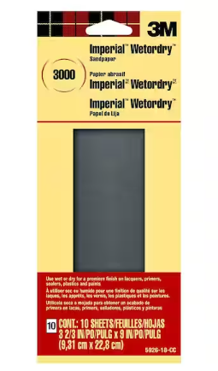 | 3000 grit | To buffer clean the valves
10 | Wipes | 1 |  | Lint free | Used to create a clean oxygen safe working environment. Also to wipe down dirty equipment.
11 | Zippered Tool Bag with pockets | 1 | 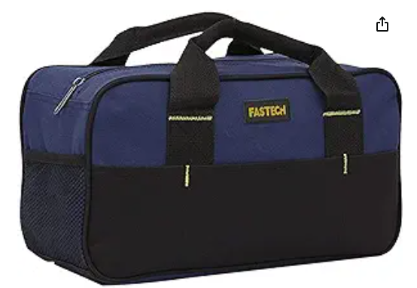 | Approximately 14in. | Used to hold all tools and keep them organized and accounted for
12 | Pick With 90 Degree Angle Tip And Straight Handle | 1 | 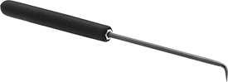 | 90 deg angle | Used for small precision movements; specifically removing ryder and compression rings.
13 | Threaded Hex bolt, M4, 40 mm long | 1 | 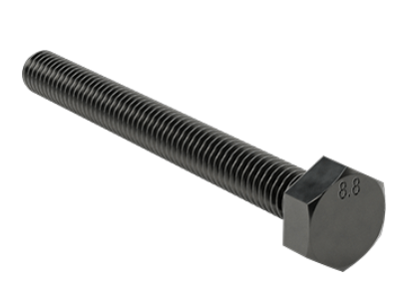 | m4 threaded hex bolt | For extracting valve assemblies for stage 2 during service
# | Item Description | Qty | Photo | Requirements / Alternatives | Tool Purpose
14 | Threaded Hex bolt, M6, 60 mm long | 1 | 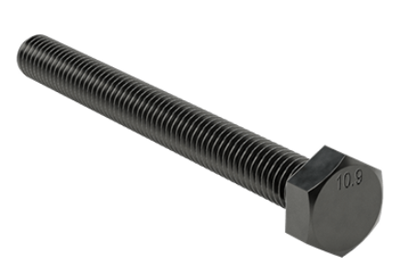 | m6 threaded hex bolt | For extracting valve assemblies for stage 1 during service
15 | Retracting-Blade Utility Knife | 1 | 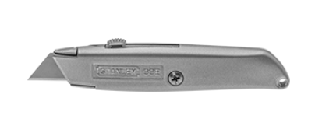 |  | Used for opening spare parts packages.
16 | 12-Point Socket Deep, Chrome Plated, 3/8" Square Drive, 17mm Size | 1 | 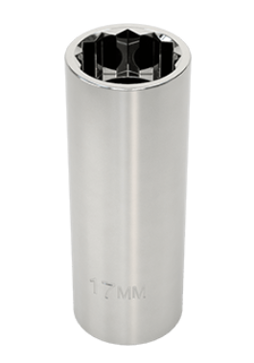 |  | Used to tighten or loosen nuts and bolts on the booster compressor
Additional tools required for maintenance that should be provided with the booster compressor by the manufacturer.
# | Item Description | Qty | Photo | Requirements / Alternatives | Tool Purpose
17 | Insertion tool HP45 | 1 | 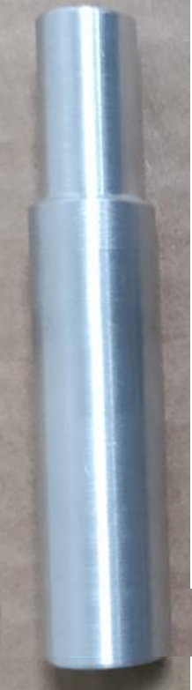 | Must be procured from manufacturer | Used to help insert piston back into sleeve and to place compression rings back onto piston.
18 | Centralizing bolt HP45 | 1 | 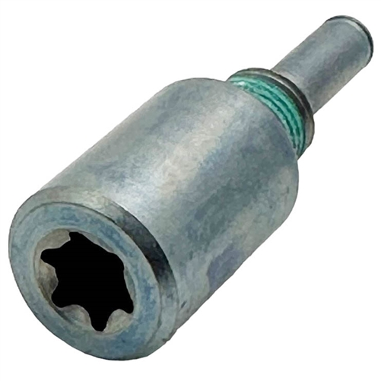 | Must be procured from manufacturer | To ensure piston and piston housing alignment.

Oxygen booster compressor tool kit: Bailian and ULTRACECO
[Applicable to models GOW-3/4-150, GOW 15/4-150 and similar and HPX models]

# | Item Description | Qty | Photo | Requirements / Alternatives | Tool Purpose
1 | Combination wrench, 10 mm | 1 |  | 10 mm | Used to turn or loosen nuts and bolts for access to PSA Plant equipment for internal maintenance or repair
2 | Combination wrench, 14 mm | 1 |  | 14 mm | Used to turn or loosen nuts and bolts for access to PSA Plant equipment for internal maintenance or repair
3 | Combination wrench, 16 mm | 1 |  | 16 mm | Used to turn or loosen nuts and bolts for access to PSA Plant equipment for internal maintenance or repair
4 | Combination wrench, 18 mm | 1 |  | 18 mm | Used to turn or loosen nuts and bolts for access to PSA Plant equipment for internal maintenance or repair
5 | Combination wrench, 19 mm | 1 |  | 19 mm | Used to turn or loosen nuts and bolts for access to PSA Plant equipment for internal maintenance or repair
6 | 12” Chrome-Plated Adjustable Wrench | 1 | 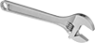 |  | Used to turn or loosen nuts and bolts for access to PSA Plant equipment for internal maintenance or repair
7 | Phillips head screwdriver | 1 |  |  | Used to insert or remove screws to access PSA Plant equipment for internal maintenance or repair
# | Item Description | Qty | Photo | Requirements / Alternatives | Tool Purpose
8 | Flat head screwdriver | 1 |  |  | Used to insert or remove screws to access PSA Plant equipment for internal maintenance or repair
9 | Ball-End Hex L-Key, 6 mm Size | 1 | 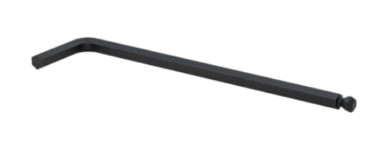 |  | Used to turn bolts or screws with hexagonal sockets to access PSA plant equipment for internal maintenance or repair. Also known as “Hex keys”
10 | Synthetic lubricant grease (2 fl oz) | 1 |  | Krytox or generic brand with equivalent specifications | Primarily lubricates o-rings; causes them to stay in place and seals from air passing.
11 | High Precision Stainless Steel Lab Tweezers | 1 |  |  | Used for small precision movements and grabbing while doing maintenance inside of the booster compressor.
12 | Pick With 45 Degree Angle Tip And Straight Handle | 1 |  | 45 degree angle | Used for small precision movements; specifically removing ryder and compression rings.
13 | Sandpaper | 1 |  | 3000 grit | To buffer clean the valves
14 | Nitrile gloves | 1 |  |  | Personal Protective Equipment (PPE). Protects technicians’ hands and keeps Oxygen Cleaned parts & tools oil free.
# | Item Description | Qty | Photo | Requirements / Alternatives | Tool Purpose
15 | Wipes | 1 |  | Lint free | Used to create a clean oxygen safe working environment. Also to wipe down dirty equipment.
16 | Zippered Tool Bag with pockets | 1 | 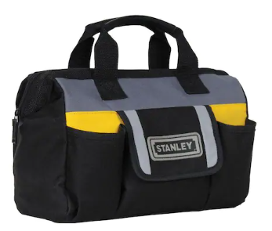 | Approximately 12in. | Used to hold all tools and keep them organized and accounted for
17 | Tight-Clearance Offset Socket, 3/8" Square Drive, 18 mm | 1 | 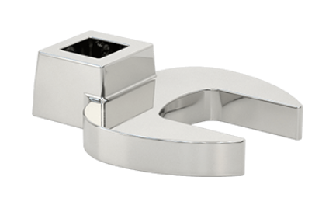 |  | Used to tighten and loosen nuts that are difficult to access with a standard wrench
18 | Wobble Socket Extension with 3/8" Square Drive | 1 | 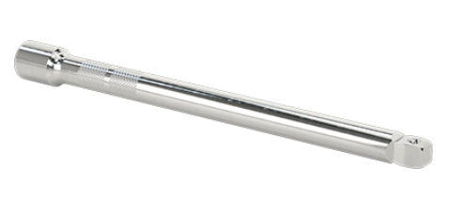 |  | Used to tighten and loosen nuts that are difficult to access with a standard wrench
19 | 4th piston ring install tool | 1 | 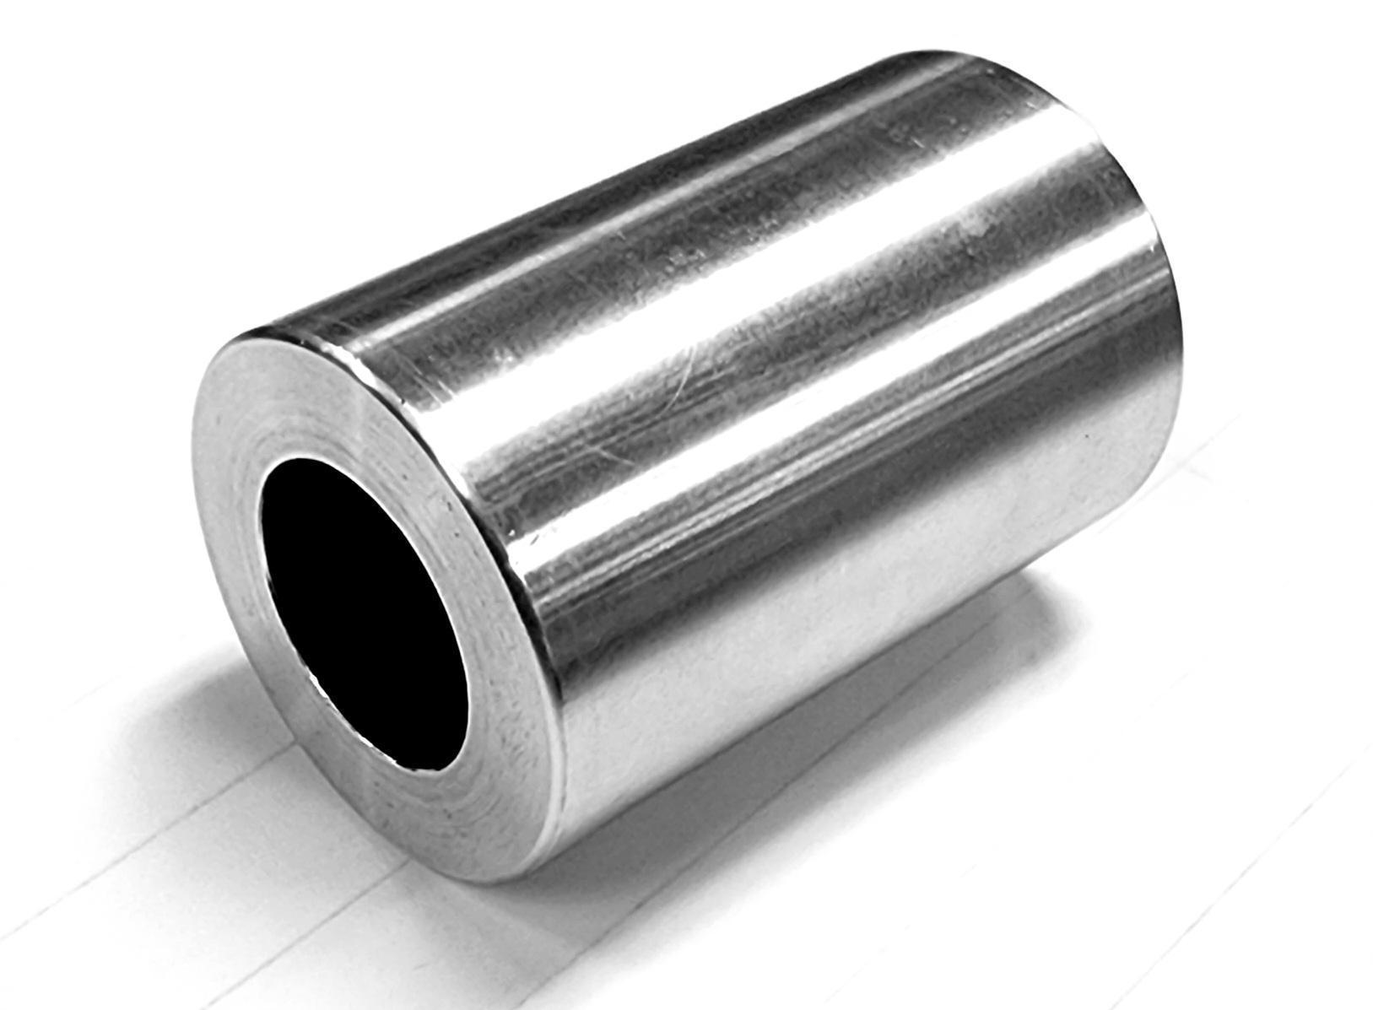 |  | Used to help insert the final stage piston back into the sleeve and to place compression rings back onto the piston.
20 | piston rod protective sleeve tool | 1 | 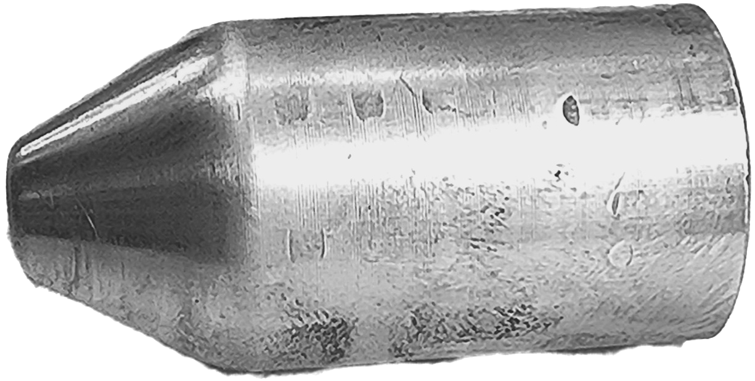 |  | Protects piston rod and compression / rider rings from being damaged during insertion
21 | Fine-Thread Alloy Steel Socket Head Screw, M6 x 0.75 mm Thread, 16 mm Long | 1 | 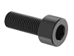 |  | Used to remove the 4th stage piston from it’s housing

5. Oxygen booster compressor tool kit: Anshan Jiapeng
[Applicable to Anshan Jiapeng models]

# | Item Description | Qty | Photo | Requirements / Alternatives | Tool Purpose
1 | Combination Wrench, 8 mm | 1 |  | 8 mm | Used to turn or loosen nuts and bolts for access to PSA Plant equipment for internal maintenance or repair
2 | Combination Wrench, 10 mm | 1 |  | 10 mm | Used to turn or loosen nuts and bolts for access to PSA Plant equipment for internal maintenance or repair
3 | Combination Wrench, 17 mm | 1 |  | 17 mm | Used to turn or loosen nuts and bolts for access to PSA Plant equipment for internal maintenance or repair
4 | Combination Wrench, 18 mm | 1 |  | 18 mm | Used to turn or loosen nuts and bolts for access to PSA Plant equipment for internal maintenance or repair
5 | Combination Wrench, 30 mm | 1 |  | 30 mm | Used to turn or loosen nuts and bolts for access to PSA Plant equipment for internal maintenance or repair
6 | 12” Chrome-Plated Adjustable Wrench | 1 |  |  | Used to turn or loosen nuts and bolts for access to PSA Plant equipment for internal maintenance or repair
7 | Phillips Head Screwdriver | 1 |  |  | Used to insert or remove screws to access PSA Plant equipment for internal maintenance or repair
8 | Flat Head Screwdriver | 1 |  |  | Used to insert or remove screws to access PSA Plant equipment for internal maintenance or repair

# | Item Description | Qty | Photo | Requirements / Alternatives | Tool Purpose
9 | Hex L-Key, 5 mm Size | 1 |  |  | Used to turn bolts or screws with hexagonal sockets to access PSA plant equipment for internal maintenance or repair. Also known as “Hex keys”
10 | Hex L-Key, 8 mm Size | 1 |  |  | Used to turn bolts or screws with hexagonal sockets to access PSA plant equipment for internal maintenance or repair. Also known as “Hex keys”
11 | Synthetic Lubricant Grease (2 Fl Oz) | 1 | 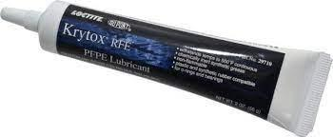 | Krytox or generic brand with equivalent specifications | Primarily lubricates o-rings; causes them to stay in place and seals from air passing.
12 | Pick with 45 Degree Angle Tip | 1 |  | 45 degree angle | Used for small precision movements; specifically removing ryder and compression rings.
13 | Nitrile Gloves | 1 |  |  | Personal Protective Equipment (PPE). Protects technicians’ hands and keeps Oxygen Cleaned parts & tools oil free.
14 | Wipes | 1 |  | Lint free | Used to create a clean oxygen safe working environment. Also to wipe down dirty equipment.
15 | 15 in. Tool Bag with 14 Pockets | 1 | 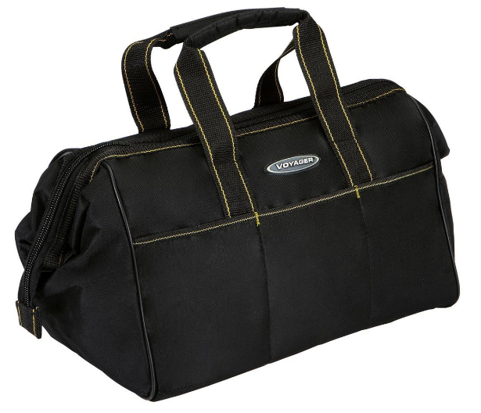 | Approximately 15in. | Used to hold all tools and keep them organized and accounted for

